

**Enterprise Web Software Development**

**Comp 1640**

Team members:

Nguyễn Minh Triết: 001392884

Nguyễn Huy Nhật Tân: 011392112

Đỗ Thành Đạt: 001392873

Trần Tuấn Thành: 001392786

Phạm Mai Nhật Trường: 001392798

Hoàng Chí Báo: 001394900

**Table of Contents**

**Group Report** 5

**1. Project Introduction** 5

**2. ERD diagram** 6

**3. Relational Schema** 6

**4. Use case diagram** 7

**5. Activity diagram** 10

**6. Sitemap** 13

**7. Sequence diagram** 16

**8. Testing** 19

**9. Agile Method: Sprint Planning, Sprint Backlogs, Schedule, Daily Meetings, Sprint Review & Retrospective Meetings, Burndown Charts** 25

**9.1 Role in sprint:** 25

**9.2 Sprint Planning:** 28

**9.3. Product Backlogs** 29

**9.4. Sprint backlog** 30

**9.5. Sprint Retrospective Meetings:** 31

**9.6. Daily stand up:** 34

**9.7. Sprint Review:** 34

**9.8. Burndown chart** 39

**9.9. Schedule** 39

**10. Wireframe** 40

**11. Product screenshots of your actual application and its functions** 52

**12. Links: Source Codes (Github), Screencast (Youtube/Google Drive/Onedrive)** 61

**References:** 62

**List of Figure**

Figure 1: ERD Diagram 7

Figure 2: Relational Schema 8

Figure 3: Use case of student 9

Figure 4: Use case of marketing coordinator 9

Figure 5: Use case of marketing manager 10

Figure 6: Use case of Admin 10

Figure 7: Use case of Guest 11

Figure 8: Student Activity Diagram 12

Figure 9: Coordinator Activity Diagram 12

Figure 10: Marketing Manager Activity Diagram 13

Figure 11: Admin Activity Diagram 14

Figure 12: Sitemap 15

Figure 13: Admin Sitemap 15

Figure 14: Student Sitemap 16

Figure 15: Marketing Coordinator Sitemap 16

Figure 16: Marketing Manager Sitemap 17

Figure 17: Student Sequence Diagram 17

Figure 18: Marketing Coordinator Sequence Diagram 18

Figure 19: Marketing Manager Sequence Diagram 18

Figure 20: Admin Sequence Diagram 19

Figure 21: Product Backlogs 31

Figure 22: Sprint 1 31

Figure 23: Sprint 2 32

Figure 24: Sprint 3 32

Figure 25: Sprint 4 32

Figure 26: Sprint 5 32

Figure 27: Meeting Sprint 1 33

Figure 28: Meeting Sprint 2 33

Figure 29: Meeting Sprint 3 34

Figure 30: Meeting Sprint 4 34

Figure 31: Daily Standup 35

Figure 32: Burndown Chart 40

Figure 33: Schedule 40

Figure 34: Login (Wireframe) 41

Figure 35: Coordinator (Wireframe) 42

Figure 36: Profile Details (Wireframe) 43

Figure 37: Coordinator Public (Wireframe) 44

Figure 38: Coordinator Pending 45

Figure 39: Coordinator Rejected (Wireframe) 46

Figure 40: Student Home Page 47

Figure 41: Academy Unactive (Wireframe) 48

Figure 42: Student Publish 49

Figure 43: Student Pending 50

Figure 44: Student Profile Details 51

Figure 45: Student Upload File 52

Figure 46: Manager (Wireframe) 53

Figure 47: Guest Management (Wireframe) 54

Figure 48: Add Guest (Wireframe) 55

Figure 49: Manager Contribution Publish (Wireframe) 56

Figure 50: Manager Contribution Publish (Wireframe) 57

Figure 51: Admin Home Page 57

Figure 52: Admin Add User Account Page 58

Figure 53: Admin Manage the Faculty Page 58

Figure 54: Admin Manage the Academy year 59

Figure 55: Marketing Coordinator Home Page 59

Figure 56: Coordinator List Blog 60

Figure 57: Contribution Detail Page 60

Figure 58: Marketing Coordinator Oversee the Contribution of Student 61

Figure 59: Marketing Profile Page 61

Figure 60: Login Page 62

Figure 61: Marketing Manager Home Page 62

Figure 62: Management List Guest Account 63

Figure 63: Add New Guest Account 63

Figure 64: Home Page for Guest 64

Figure 65: Guest view the Published Contributions 64

Figure 66: Student add a new contribution 65

Figure 67: When student add a new contribution successfully 65

# **Group Report**

## **1. Project Introduction**

The web-based system with secure role-based mechanism that collects student contributions for a yearly university magazine is to be essential and since it is through this that the magazine production process will be improved in the university. The mission of the Marketing Manager is to provide on-going support and supervision as each Faculty is supplied with a Marketing Coordinator who is in charge of administration and editorial creativity of their respective departments. Under the guidance, system, all of the students can submit their ideas and aesthetic images, which will build up a fair and comprehensive thematic publication. By limiting the submission dates to agreed dates of closure and giving updates until the original closure date, the system can guide the work through a managed process and an efficient system. Furthermore, the Terms and Conditions agreement which takes care of compliance and uses statistics for better surveillance is implemented during the course of the submission process. Through automatic email notifications, Marketing Coordinators are immediately informed of the appearance of new submissions and are tasked with responding to them within the range of a given timeframe. Beyond that, by designing this method, the System Assistants can help "Students", be "Edited" and "Published", which consequently promotes communication and the interaction of both parties, thus giving birth to cooperation. The university marketing manager has the access to all contributions but s/he cannot edit the messages, therefore connects dots between marketing strategies. In addition, administrator maintains system data such as academic years closing dates, while guest accounts that students use to study are able to see only particular reports for all Faculty depending on permissions. The system has been equipped with statistical analysis capabilities as well as a user-friendly interface designed to work on all devices. The platform thereby ensures transparency, efficiency and inclusion for everyone involved in the magazine publication process.

## **2. ERD diagram**

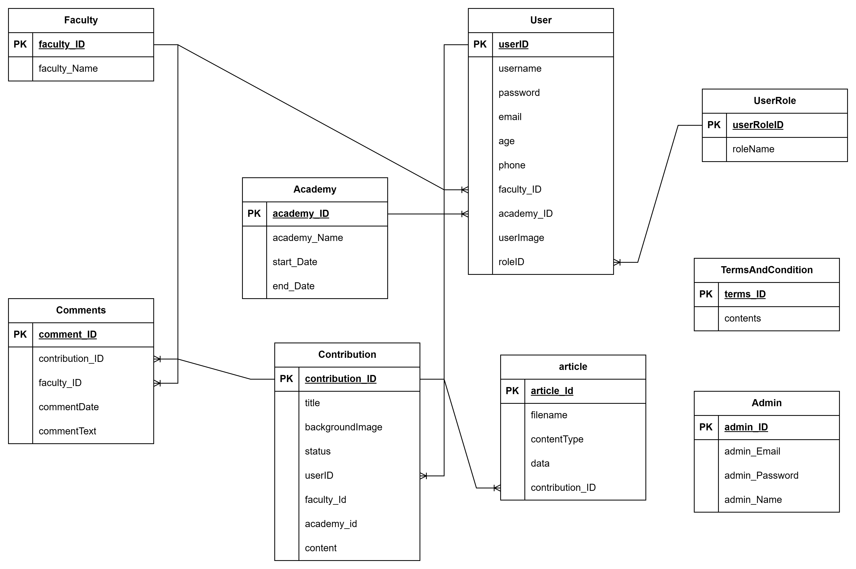

Figure 1: ERD Diagram

## **3. Relational Schema**

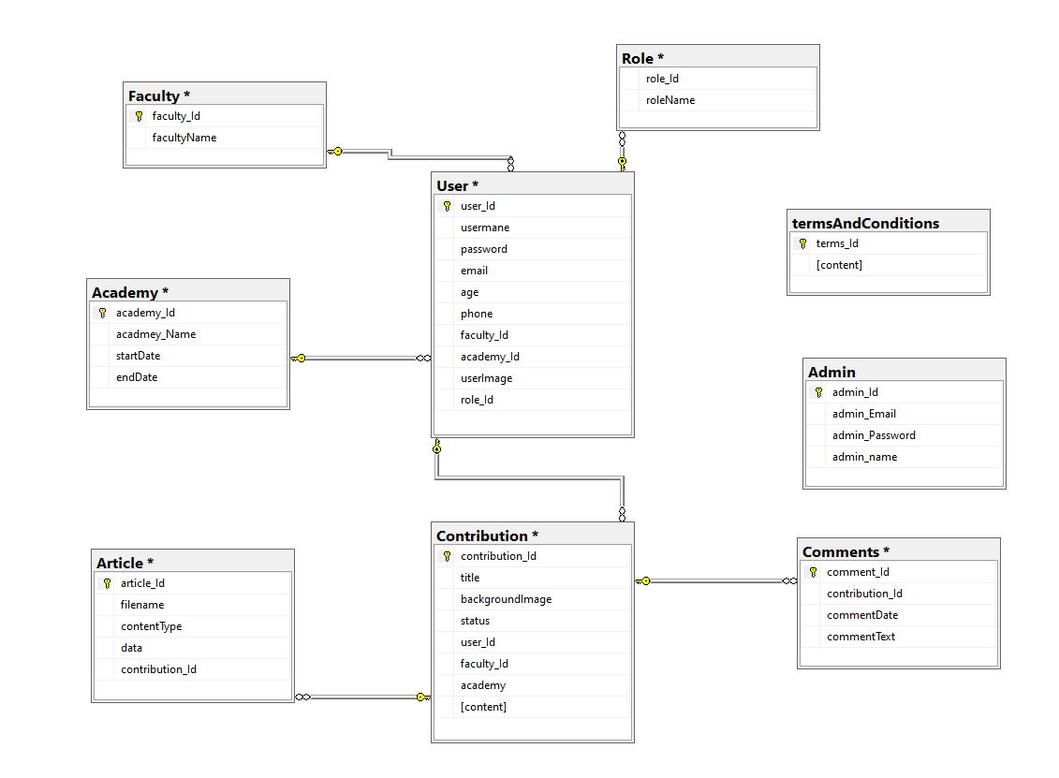

Figure 2: Relational Schema

## **4. Data Dictionary**

4.1. User table

|  |  |  |  |
| --- | --- | --- | --- |
| Field Name | Data Type | Constraint | Description |
| user_Id | Varchar | Primary Key | User’s id, Auto generated |
| User_name | Varchar | Not null | Name of user |
| Password | Varchar | Not null | Login password for user |
| Email | Varchar | Not null | Login email for user |
| Age | Int | Not null | Age of user |
| Phone | Varchar | Not null | Phone number of user |
| Faculty_id | Varchar | Foreign key | Any faculty id |
| Academy_id | Varchar | Foreign key | Any academy id |
| userImage | Varchar | Not null | Avatar of user |
| roleId | Varchar | Foreign key | Any role id |

4.2. Admin table

|  |  |  |  |
| --- | --- | --- | --- |
| Field Name | Data Type | Constraint | Description |
| admin_id | Varchar | Primary Key | admin’s id, Auto generated |
| admin_Email | Varchar | Not null | email of admin |
| Password | Varchar | Not null | Login password for admin |
| Admin_name | Varchar | Not null | Name of admin |
| Age | Int | Not null | Age of user |

4.3. Article Table

|  |  |  |  |
| --- | --- | --- | --- |
| Field Name | Data Type | Constraint | Description |
| Article_id | Varchar | Primary Key | article’s id, Auto generated |
| filename | Varchar | Not null | File’s name |
| contentType | Varchar | Not null | Type of content (word) |
| data | varchar | Not null | All data in uploaded file |
| Contribution_ID | varchar | Foreign key | Any contribution_Id |

4.4. Faculty Table

|  |  |  |  |
| --- | --- | --- | --- |
| Field Name | Data Type | Constraint | Description |
| Faculty_id | Varchar | Primary Key | faculty’s id, Auto generated |
| Faculty_name | Varchar | Not null | Name of faculty |

4.5. Academy Table

|  |  |  |  |
| --- | --- | --- | --- |
| Field Name | Data Type | Constraint | Description |
| Academy_id | Varchar | Primary Key | academy’s id, Auto generated |
| Academy_name | Varchar | Not null | Academy’s name |
| Start_Date | Datetime | Not null | Start date of academy |
| End_Date | Datetime | Not null | End date of academy |

4.6. Comment Table

|  |  |  |  |
| --- | --- | --- | --- |
| Field Name | Data Type | Constraint | Description |
| Comment_id | Varchar | Primary Key | comment’s id, Auto generated |
| content | Varchar | Not null | Contents of coment |
| User_Id | Varchar | Foreign Key | Any user id |
| Contribution_id | Varchar | Foreign key | Any contribution id |
| createAt | Date | Not null | Auto generated, time when comment created. |

4.7. Role Table

|  |  |  |  |
| --- | --- | --- | --- |
| Field Name | Data Type | Constraint | Description |
| Role_id | Varchar | Primary Key | role’s id, Auto generated |
| Role_name | Varchar | Not null | Name of role |

4.8. Terms and Conditions Table

|  |  |  |  |
| --- | --- | --- | --- |
| Field Name | Data Type | Constraint | Description |
| Terms_id | Varchar | Primary Key | terms’s id, Auto generated |
| Content | Varchar | Not null | Terms and condition contents |

4.9. Contribution Table

|  |  |  |  |
| --- | --- | --- | --- |
| Field Name | Data Type | Constraint | Description |
| Contribution_Id | Varchar | Primary Key | contribution’s id, Auto generated |
| Title | Varchar | Not null | Title of the contribution |
| backgroundImage | Varchar | Not null | Background Image of contribution |
| Status | Varchar | Not null | status of contribution |
| User_Id | Varchar | Foreign key | Any user id |
| Faculty_Id | Varchar | Foreign key | Any faculty id |
| Academy_Id | Varchar | Foreign key | Any academy id |
| Content | Varchar | Not null | Content of contribution |

## **5. Use case diagram**

Use case of student

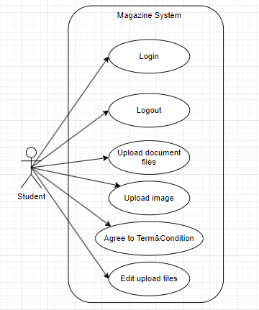

Figure 3: Use case of student

Use case of marketing coordinator

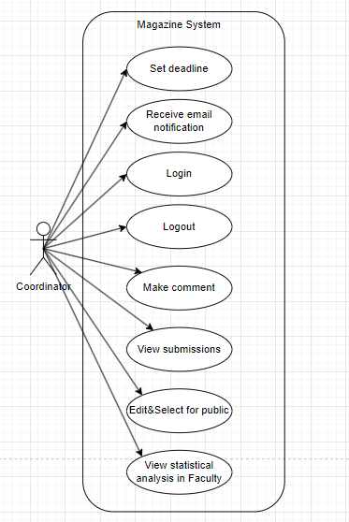

Figure 4: Use case of marketing coordinator

Use case of marketing manager

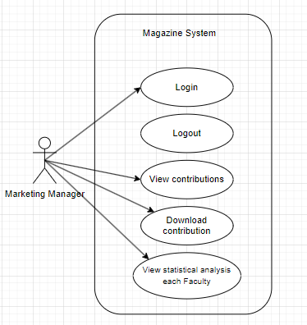

Figure 5: Use case of marketing manager

Use case of Admin

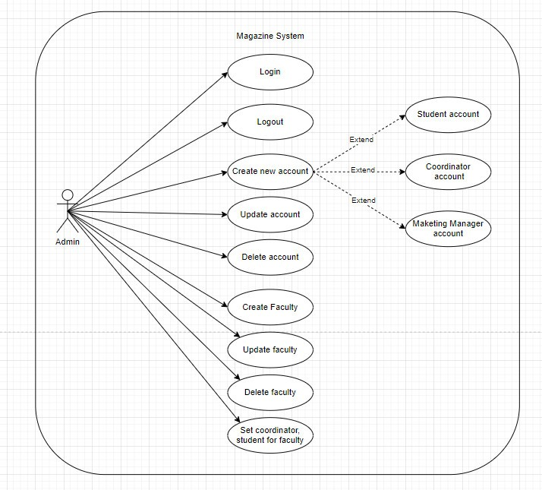

Figure 6: Use case of Admin

Use case of Guest

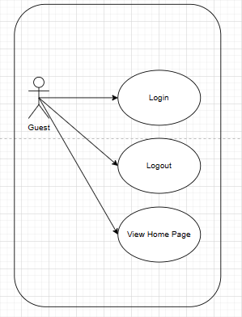

Figure 7: Use case of Guest

## **6. Activity diagram**

The activity diagram of Students shows a stepwise approach that begins with a student login. After inputting its details, the system authenticates itself. If the student is resourceful, he/she can download an image or document after a successful submission. Authentication error is displayed and let the retry is an option to log in. Finally, irrespective of student's status of the authentication the student eventually logs out.

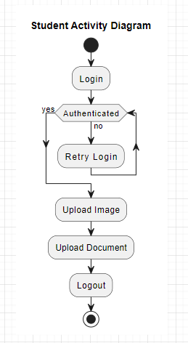

Figure 8: Student Activity Diagram

The coordinator activity diagram clearly describes the sequence that the coordinator should follow to try logging into the system. After logging in with the system, it checks if given access is approved to the coordinator. If successful, the coordinator of the petitions becomes the owner of a few duties, namely reading in entries, editing the written contributions, leaving comments, and publication of the submissions. Should the authentication fail, the system will display information on how to do the same action again. Finally, the coordinator logs out, where authentication issue ceases to matter.

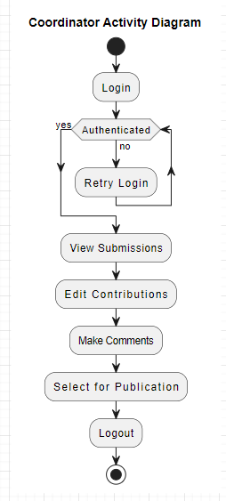

Figure 9: Coordinator Activity Diagram

This activity diagram shows what a marketing manager goes through to bring together ideas and hand them over to the departments concerned. The supervisor opens the system and sees a list from which he can separately select the contributions, by several methods. This would enable them to pick contributions of their choice and download them for further examination. Use our AI to write for you about any topic! Enjoy Ultimately, upon finishing the review stage, the employee logs out of the online system. This diagram can be used to comprehend the workflow of the process, but it does not pinpoint exact channels or any constraints.

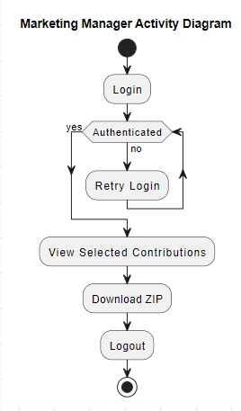

Figure 10: Marketing Manager Activity Diagram

The Admin Activity Diagram reveals how an admin navigates the system after providing a login. In the first step the user enter a name and password which will be inspected for authentication. After that, the admin can leverage the data in the system to view reports, manage accounts and publications, and finally log out. Another security feature that logins include is passphrase failure. In this case, the admin can proceed to retry the login process.

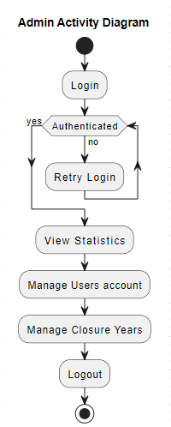

Figure 11: Admin Activity Diagram

## **7. Sitemap**

The website map drawn below provides the framework of the site by revealing its pages and directories. It contributes to the success of a website by both guiding users to the desired content and supporting search engine indexing. Webpages would include Home, About Us, Contact Us, Login, Create Account, Edit Account, Delete Account, Account Management, Admin Panel, Closing Day, Academy, Students, Marketing Management, Guest Invitation, Submitting and Viewing comments. Accessing contributions and Commenting contributions. On our web page, the highlight is links between pages and directories such as Home and About Us, Contact Us, Login, Create Account, and Account Management demonstrating a well desirable structure.

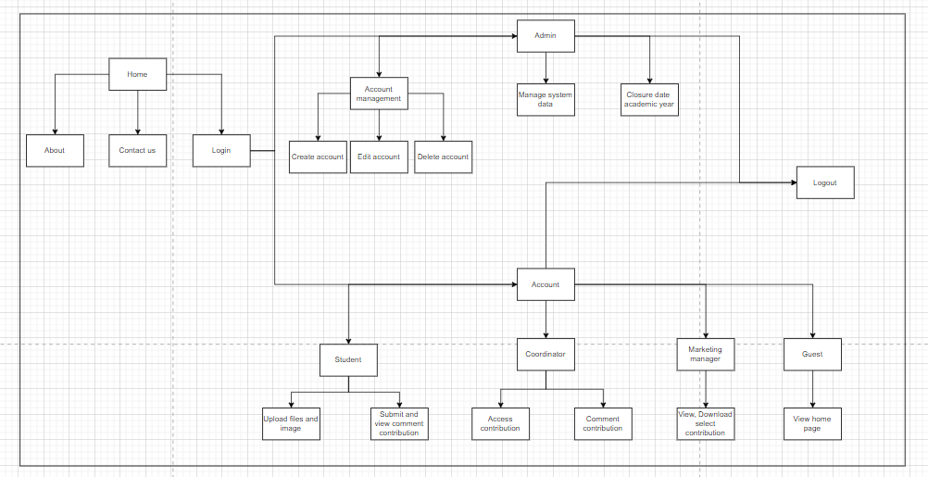

Figure 12: Sitemap

Admin Sitemap

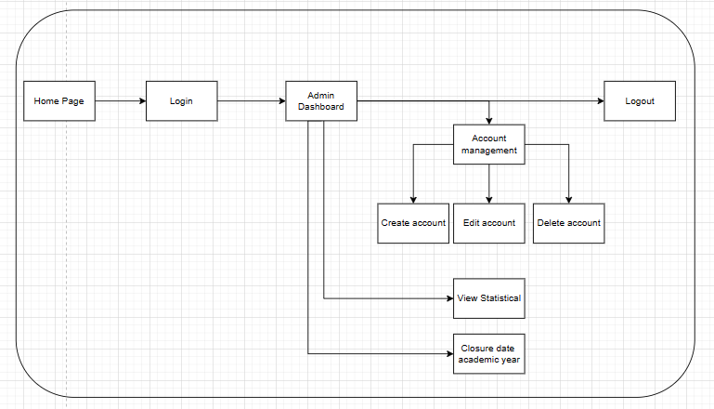

Figure 13: Admin Sitemap

Student Sitemap

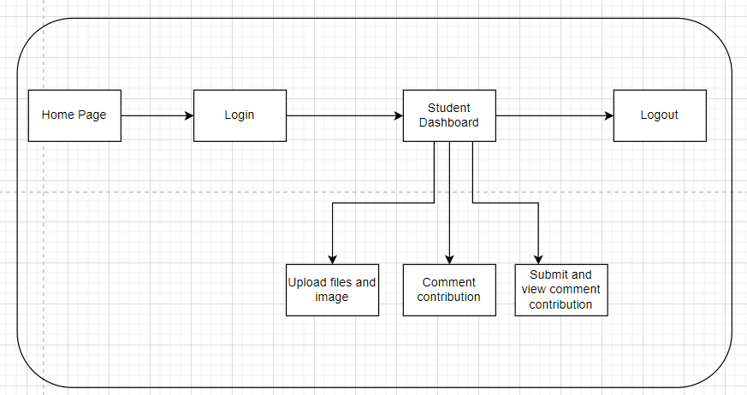

Figure 14: Student Sitemap

Marketing Coordinator

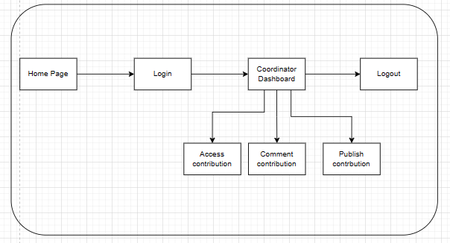

Figure 15: Marketing Coordinator Sitemap

Marketing Manager

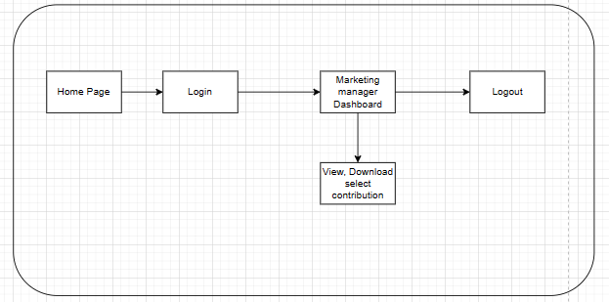

Figure 16: Marketing Manager Sitemap

## **8. Sequence diagram**

Student sequence diagram

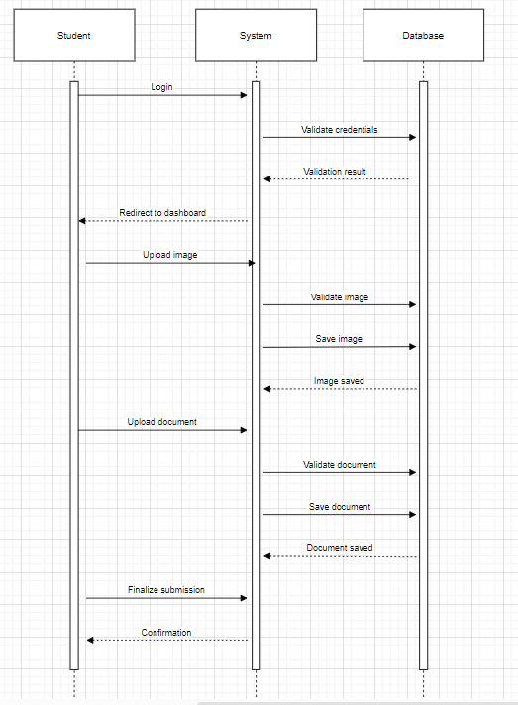

Figure 17: Student Sequence Diagram

Marketing coordinator sequence diagram

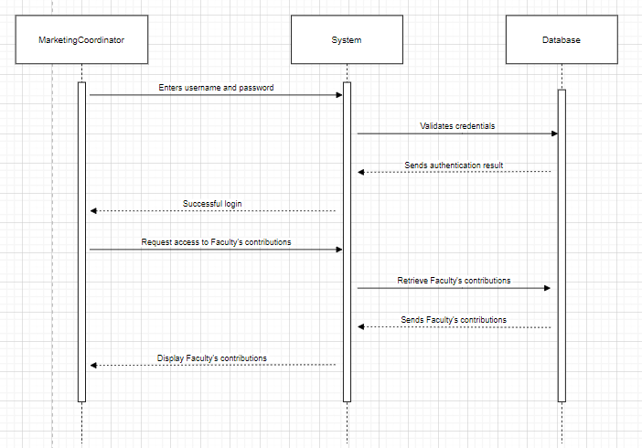

Figure 18: Marketing Coordinator Sequence Diagram

Marketing Manager Sequence Diagram

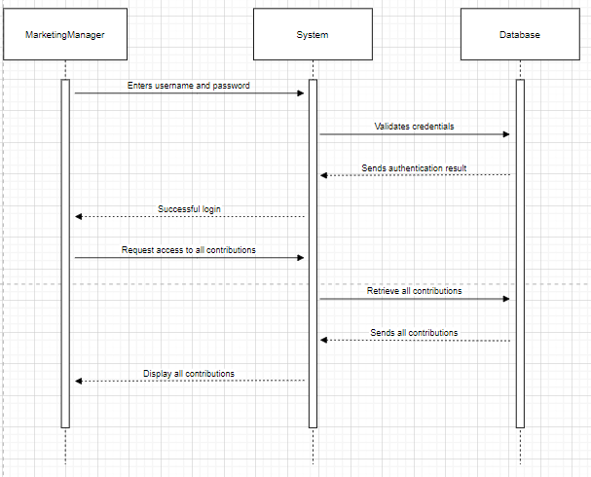

Figure 19: Marketing Manager Sequence Diagram

Admin Sequence Diagram

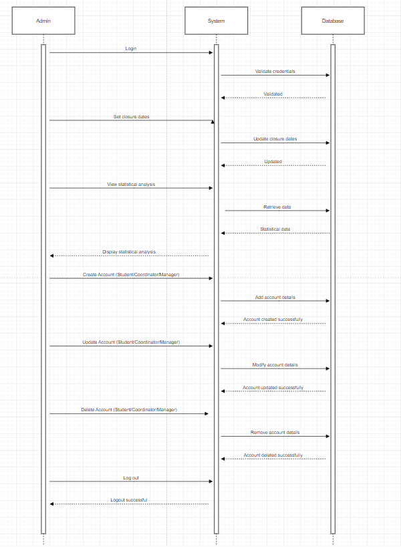

Figure 20: Admin Sequence Diagram

# 

## **9. Testing**

|  |  |  |  |  |  |
| --- | --- | --- | --- | --- | --- |
| No. | Function | How to test | Expected test results | Actual test  results | Pass /  Fail |
|  | Login to system | Login by Admin account  Name: [admin@gmail.com](mailto:admin@gmail.com)  Pass: 1234567 | Login successful | Login successful | Pass |
|  | Logout to system | Logout by Admin account | Logout successful | Logout successful | Pass |
|  | Create student account | Input Information  Name: Test 1  Gmail: [Test1@gmail.com](mailto:Test@gmail.com)  Faculty: Design  Password: 1234567  Gender: Male  Image: Test1.jpg  City: Ho Chi Minh  Phone: 001  Role: Student | Create student account name Test 1 | Create student account name Test 1 successful | Pass |
|  | Create student account | Input Information  Name: Test 2  Gmail: [Test2@gmail.com](mailto:Test@gmail.com)  Faculty: Computing  Password: 1234567  Gender: Male  Image: Test2.jpg  City: Ho Chi Minh  Phone: 002  Role: Student | Create student account name Test 2 | Create student account name Test 2 successful | Pass |
|  | Create student account | Input Information  Name: Test 3  Gmail: [Test3@gmail.com](mailto:Test@gmail.com)  Faculty: Business  Password: 1234567  Gender: Female  Image : Test3.jpg  City : Ho Chi Minh  Phone : 001  Role : Student | Create student account name Test 3 | Create student account name Test 3 successful | Pass |
|  | Re-create an existing student account | Input Information  Name : Test 1  Gmail: [Test1@gmail.com](mailto:Test@gmail.com)  Faculty : Business  Password: 1234567  Gender : Female  Image : Test1.jpg  City : Ho Chi Minh  Phone : 001  Role : Student | Notification that the account already exists | Notification that the account already exists | Pass |
|  | Create student account | Input Information  Name : Test 4  Faculty : Business  Password: 1234567  Gender : Female  Image : Test4.jpg  City : Ho Chi Minh  Phone : 004  Role : Student | Do not add an account without enough information | Notice that information is missing and must be supplemented if you want to add an account | Pass |
|  | Create marketing manager account | Input Information  Name: Marketing Manager 1  Faculty: Business  Password: 1234567  Gender: Female  Image: manager1.jpg  City: Ho Chi Minh  Phone: 12345  Role: Manager | Create marketing manager account name Marketing Manager 1 | Create marketing manager account name Marketing Manager 1 successful | Pass |
|  | Create marketing manager account | Input Information  Name: Marketing Manager 2  Faculty: Business  Password: 1234567  Gender: Female  Image: manager2.jpg  City: Ho Chi Minh  Phone: 12345  Role: Manager | Phone number information is duplicated and must be re-entered | Re-entered phone number information successfully | Pass |
|  | Create Coordinator account | Input Information  Name: Coordinator 1  Faculty: Business  Password: 1234567  Gender: Female  Image: coordinator1.jpg  City: Ho Chi Minh  Phone: 0008  Role: coordinator | Create coordinator account name Coordinator 1 | Create coordinator account name Coordinator 1 successful | Pass |
|  | Edit account student | Edit account student  Name: Test 1 => Test 1 new | Update account student | Update account student successful | Pass |
|  | Edit account student | Edit account student  Name: Test 1 new  Gmail: Test1gmail.com  => test@gmail.com  Account is duplicated: Name test  Gmail: test@gmail.com | Edit an existing student gmail account that overlaps with another account | Notice of duplicate gmail and request to re-enter | Pass |
|  | Update image student | Update account student  Name: Test 1 new | Update new image | Update new image successful | Pass |
|  | Update image marketing manager | Update account marketing manager  Name: Marketing Manager 1 | Update new image | Update new image successful | Pass |
|  | Update image coordinator | Update account coordinator  Name: Coordinator | Update new image | Update new image successful | Pass |
|  | Delete account student | Delete account student  Name: Test 1 new | Delete account student | Delete account studen007 successful | Pass |
|  | Delete marketing manager account | Delete account Marketing Manager  Name: Marketing Manager 1 | Delete account marketing manager | Delete account marketing manager successful | Pass |
|  | Delete coordinator account | Delete account coordinator  Name: Coordinator | Delete account coordinator | Delete account coordinator successful | Pass |
|  | Check Terms and Conditions before submit contribution | Terms and Conditions: You must agree to the user terms | If not check the box before submit will pop up alert | Check the box before submit contribution and contribution submit successful | Pass |
|  | Create Academy | Input information Academy  Name: test academy  Description: test academy Start date: 7/4/2024  End date: 10/4/2024 | Create Academy | Create Academy successful | Pass |
|  | Edit name Academy | Edit information Academy  Id: 03  Name: test academe  => test academe new  Description: test academe Start date: 7/4/2024  End date: 10/4/2024 | Edit name Academy | Edit Name Academy successful | Pass |
|  | Delete Academy | Delete information Academy  Id: 03  Name: test academy new  Description: test academy Start date: 7/4/2024  End date: 10/4/2024 | Delete Academy | Delete Academy successful | Pass |
|  | Login account student | Login account student name Test 1 | Login successful | Login successful | Pass |
|  | Check academy | Academy is still valid | Blogs can be added | Successful | Pass |
|  | Check academy | Academy is no longer valid | Cannot add blog | Successful | Pass |
|  | Submit contribution | Input information in submission form  Title: Blog test1  Content: Blog test1  Upload Background Image:  Test1.jpg  Upload File: testaddblog.docx  Click box: terms and conditions | Submit contribution successful | Submit contribution successful | Pass |
|  | Submit contribution | Input information in submission form  Title: Blog test2  Content: Blog test2  Upload Background Image:  Test2.jpg  Upload File: testaddblog.docx  Click box: terms and conditions | Submit contribution successful | Submit contribution successful | Pass |
|  | Logout account student | Logout account student name Test 1 | Logout successful | Logout successful | Pass |
|  | Login account coordinator | Login account coordinator name Coordinator 1 | Login successful | Login successful | Pass |
|  | Comments in student contribution | comment on contribution name: Blog test 1 | Comment contribution successful | Comment contribution successful | Pass |
|  | Logout coordinator account | Logout account coordinator name Coordinator 1 | Logout successful | Logout successful | Pass |
|  | Login marketing manager account | Login account marketing manager name Marketing Manager 1 | Login successful | Login successful | Pass |
|  | Create guest account | In marketing manager account create guest account  Input gmail, name, password, phonenumber, image, city | Create guest account | Create guest account successful | Pass |
|  | Edit guest account | In marketing manager account create guest account  Guest account information can be edited | Edit guest account | Edit guest account successful | Pass |
|  | Delete guest account | In marketing manager account create guest account  Guest account information can be deleted | Delete guest account | Delete guest account successful | Pass |
|  | Download contribution | Download published contribution | Download  successful | Download contribution successful | Pass |
|  | Logout account marketing manager | Logout account marketing manager name Marketing Manager 1 | Logout successful | Logout successful | Pass |
|  | Upload image | Upload file in system | Not allowed to upload and forced to re-upload the image | Successful | Pass |
|  | Upload image | Upload image in system | Upload successful | Successful | Pass |
|  | Upload file | Upload images or other files other than .pdf to the system | Not allowed to upload and forced to re-upload the .pdf file | Successful | Pass |
|  | Upload file | Upload file in system | Upload successful | Successful | Pass |

## **10. Agile Method: Sprint Planning, Sprint Backlogs, Schedule, Daily Meetings, Sprint Review & Retrospective Meetings, Burndown Charts**

### **10.1 Role in sprint:**

**Scrum Master (Do Thanh Dat)**

Ensure that the Scrum process is adhered to and implemented correctly throughout the project.

Organize and facilitate Scrum events, including sprint planning, daily stand-ups, sprint reviews, and sprint retrospectives.

Support the development team in resolving impediments and challenges, ensuring continuous progress and effectiveness.

Build a positive work environment and support the personal development of team members.

Help to remove obstacles and foster collaboration and autonomy within the team.

Ensure that the final product meets customer requirements and achieves business goals.

Monitor and evaluate the performance of the team and the Scrum process, and propose improvements as necessary.

**Product Owner (Hoang Chi Bao)**

Identify and prioritize product requirements in the product backlog based on business value and customer feedback.

Plan and manage the product backlog, including analyzing requirements, setting priorities, and preparing user stories.

Participate in sprint planning meetings to ensure that the sprint goals are understood and achieved.

Provide feedback and guidance to the development team, ensuring that customer requirements are understood and implemented correctly.

Ensure that the product is developed to meet customer needs and achieve business goals.

Continuously assess and update the product backlog to reflect changes in requirements or priorities.

Make final decisions on the scope and priorities of the product, and provide feedback on team performance.

**Development Team:**

Front-end Developer (Nguyen Minh Triet):

**User Interface Design:**

Design admin interface

Design marketing coordinator interface

Design student interface

Design marketing manager interface

Supports interface's adaptability to any screen size and simultaneous responsiveness.

**Submission Form:**

Give students a form to submit image and article and specify fields like title, content, author, etc.

Make possible the ease of inserting pictures and documents from different sources.

**Faculty Interface:**

Make an interface to present to the Marketing Coordinator a list of students' post, belonging to their Department.

Embrace the roles of editing and selecting articles for publishing.

**Notification System:**

Design email template

**Statistical Analysis:**

Design simple tables and graphs to provide the user with graphical data they can monitor and evaluate.

**Back-end Developer (Nguyen Huy Nhat Tan):**

Implement authentication and authorization for user which is centralized.

Include functions like admin create, update, delete the account and write a closure date for all year academic.

Commenting feature for Manager of marketing feels free to give his comments on student participation.

An Marketing coordinator in their faculty is able to contribute with the choice and publication of selected pieces.

Designing a report management system, among the features which it would comprise would be report creation, editing, deletion and the ability to view the list of submitted reports.

The function for the Marketing Manager to get contribution report and select download must be created.

Of course, the app will have student function and will require the user to simply upload image and contribution

Make an authorization system for Marketing Coordinators to view and alter those of their faculty only.

Develop the function to send emails to users upon their reports sent or inquiries made for edits.

Develop statistical to show the contribution number.

**Database Develop and Design Diagram (Tran Tuan Thanh):**

Create tables for objects such as Faculty, Admin, Users, User role, Academy, Comment, Term and Condition, Contribution, Contribution-item

Determine relationships between tables.

Identify the required data fields for each table and their data types.

Design an ERD diagram describing the database structure.

Design website sitemap for Admin, Marketing coordinator, Marketing manager, Student.

Design activity diagram for Admin, Marketing coordinator, Marketing manager, Student.

Design sequence diagram for roles in website.

Implement role-based access control and user management, ensuring only authorized users have access and perform necessary operations.

Optimize MongoDB database queries to ensure high performance and reliability when handling requests from users.

Deploy the database on production environments and maintain the system to ensure continuous and stable operations.

**Tester ( Pham Mai Nhat Truong) :**

Develop testing plans and prepare testing documents, including test cases, test scenarios, and test data.

Participate in identifying testing requirements from the product backlog and planning testing for each sprint.

Execute tests to check the functionality and quality of the product, including functional, performance, security, and compatibility testing.

Record and report bugs or quality issues to the development team for resolution.

Support the team in automating testing and deploying automated testing tools to optimize the testing process.

Attend sprint review meetings to provide feedback on the product's quality and suggest improvements.

Continuously update and maintain testing scripts to ensure that the product meets quality requirements and customer expectations.

### **10.2 Sprint Planning:**

|  |  |  |  |
| --- | --- | --- | --- |
| Task | Role | Duration (hours) | Timescale |
| Sprint Planning - Sprint 1 | Scrum Master | 1-2 | Week 1 |
| Validate project direction with stakeholders. Ensure ERD and Use Case Diagram reflect stakeholder needs. Enhance UI design for usability and branding. | Product Owner, Development Team | 1-2 | Week 1 |
| Sprint Planning - Sprint 2 | Scrum Master | 1-2 | Week 2 |
| Develop a user-friendly login interface for admins and users. Create an intuitive information management interface for admins. | Product Owner, Development Team | 1-2 | Week 2 |
| Sprint Planning - Sprint 3 | Scrum Master | 1-2 | Week 3 |
| Design site map and activity diagram. Implement article submission and notification system. Introduce student agreement page for file uploads. | Product Owner, Development Team | 1-2 | Week 3 |
| Sprint Planning - Sprint 4 | Scrum Master | 1-2 | Week 4 |
| Implement System Data Management and Marketing Coordination. Develop a statistical analysis dashboard for faculty contributions. | Product Owner, Development Team | 1-2 | Week 4 |
| Sprint Planning - Sprint 5 | Scrum Master | 1-2 | Week 5 |
| Develop a dashboard for marketing manager to access magazine contributions. Optimize website for accessibility and responsive design on all devices. | Product Owner, Development Team | 1-2 | Week 5 |

### **10.3. Product Backlogs**

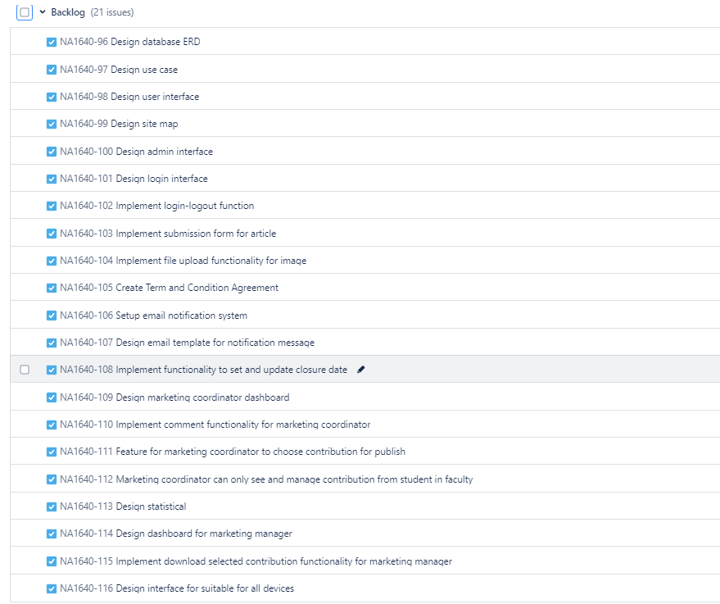

Figure 21: Product Backlogs

### **10.4. Sprint backlog**

Sprint 1

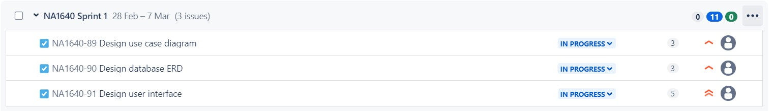

Figure 22: Sprint 1

Sprint 2

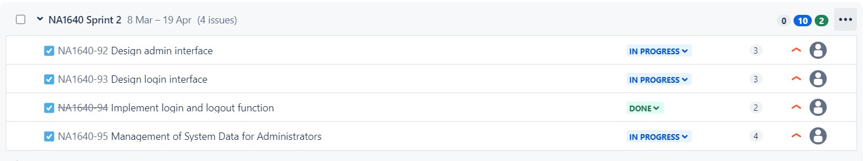

Figure 23: Sprint 2

Sprint 3

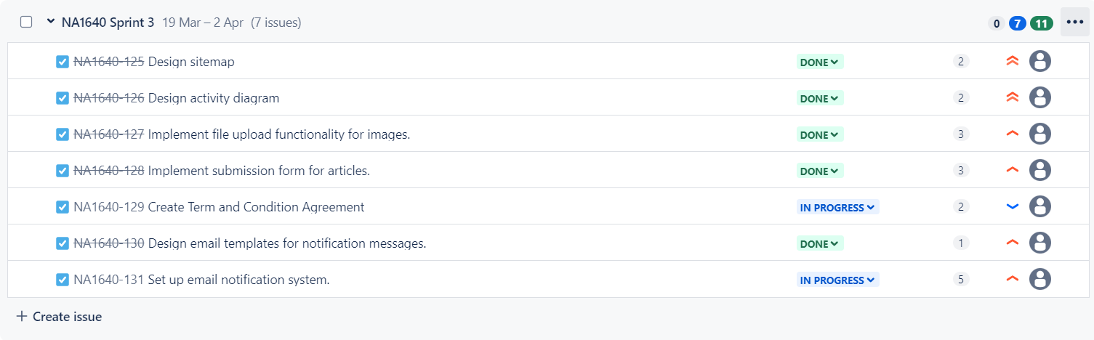

Figure 24: Sprint 3

Sprint 4

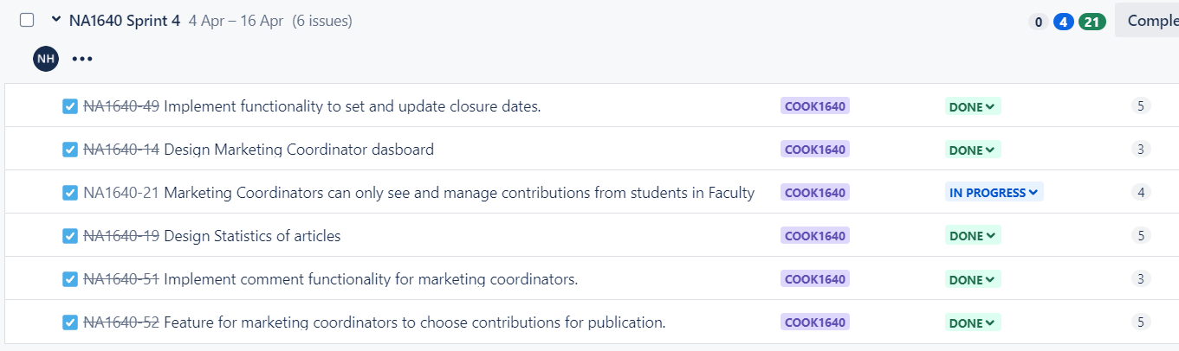

Figure 25: Sprint 4

Sprint 5

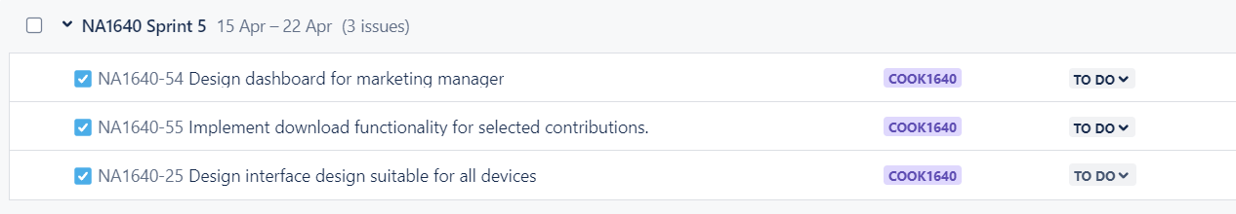

Figure 26: Sprint 5

### **10.5. Sprint Retrospective Meetings:**

Meeting Srint 1

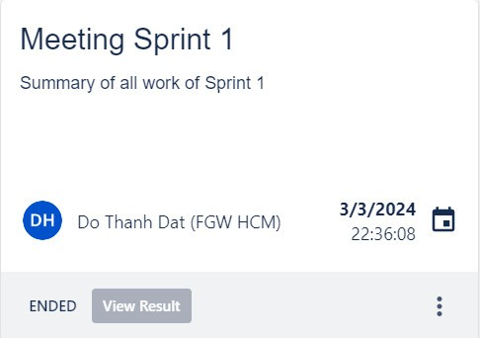

Figure 27: Meeting Sprint 1

Meeting Sprint 2

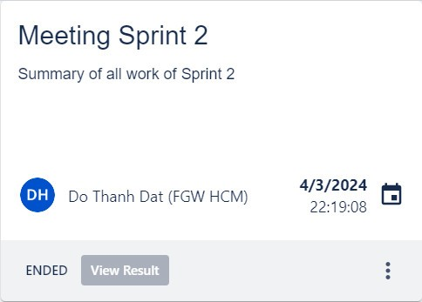

Figure 28: Meeting Sprint 2

Meeting Sprint 3

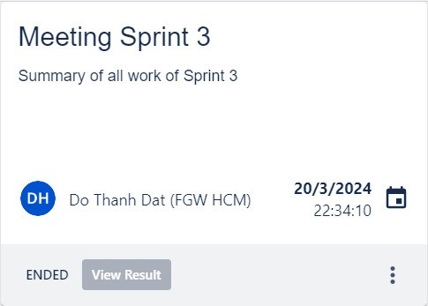

Figure 29: Meeting Sprint 3

Meeting Sprint 4

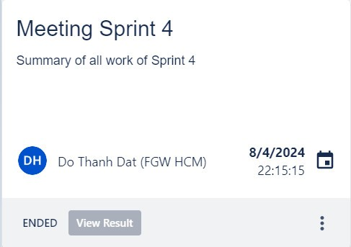

Figure 30: Meeting Sprint 4

### **10.6. Daily Standup:**

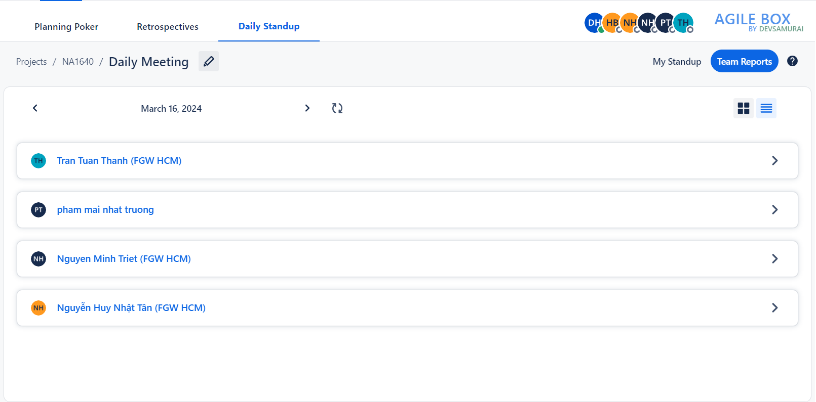

Figure 31: Daily Standup

### **10.7. Sprint Review:**

**Sprint review – Sprint 1**

Our three-pronged sprint aim was:   
Verify that the project's course meets the needs and expectations of the stakeholders.   
Verify that the requirements listed in the ERD and Use Case Diagram accurately reflect the needs of the stakeholders.   
To improve the UI design's usability, intuitiveness, and branding alignment, get user feedback.  
Feedback Gathering  
Validation of Requirements  
User Interface Validation  
Early Issue Identification

|  |  |
| --- | --- |
| Demo instructions | Feedback |
| Requirements Team: Validate that the project's direction aligns with stakeholders' expectations and requirements, showcasing alignment with ERD and Use Case Diagram. | Suggest conduct a thorough review with a wider group of stakeholders to ensure we capture all necessary needs accurately |
| Development Team: Confirm the accuracy of requirements captured in the ERD and Use Case Diagram, demonstrating how the system's behavior and data model meet stakeholders' needs. | Stakeholder desires increased accuracy. |
| UI/UX Team: Gather feedback on the UI design, showcasing visualizations of the system's look and feel and soliciting feedback on usability, intuitiveness, and branding alignment**.** | Gather direct feedback from end-users. This will allow us to identify any potential usability issues and make refinements to further improve the user experience. |

**Complete and deliver to the client:**  
Having illustrations and an overview of the features that consumers requested demonstrates the team's professionalism in promoting job progress.

**Sprint review – Sprint 2**

**Sprint goal Top of Form**

In Sprint 2, our goal was to deploy processes identified in Sprint 1 and prioritize two key tasks:

* Creation of a user-friendly login interface for administrators and users.
* Development of an intuitive information management interface tailored for administrators.

|  |  |
| --- | --- |
| Demo instructions | Feedback |
| Login Interface: Demonstrate the user-friendly login interface designed for seamless system access by both administrators and regular users. | Meets usability standards for both administrators and users. The interface is intuitive, making it easy for users to access the system seamlessly. However, Stakeholder suggest considering additional user authentication options such as multi-factor authentication to enhance security further. |
| Information Management Interface: Showcase the intuitive interface providing administrators with effective tools for overseeing and managing critical system data. | Recommend incorporating customizable reporting features to provide administrators with greater insights into system usage and performance. |

**Complete and bring to Client**

We have successfully delivered the interface exactly as requested by our customers, seamlessly integrating essential features like login, logout, and an intuitive admin management interface. This achievement reflects our commitment to meeting and exceeding customer expectations, ensuring a smooth and user-friendly experience for all users.

**Sprint review – Sprint 3**

**Sprint goal** Top of Form

We will come up with the next design of the site, namely the site map and activity diagram. Focus to implement function that help user can submission article also create a notification system for each submission contribution to Marketing coordinator. At last, will have a page for student agreement when students upload file.

* Develop the site map and activity diagram for the next design iteration.
* Implement features to facilitate user article submissions.
* Create a notification system to alert the Marketing Coordinator of each submission contribution.
* Introduce a page for student agreement during file uploads.

|  |  |
| --- | --- |
| Demo instructions | Feedback |
| Design Team: Showcase the finalized site map and activity diagram for the upcoming design iteration. | Adjusted and corrected symbol errors for diagrams and some logic in the system. |
| Development Team: Demonstrate the functionality allowing users to submit articles and the notification system implemented for the Marketing Coordinator. | Some submission formats are missing and need to be added. |
| UI/UX Team: Present the student agreement page design and its integration into the file upload process. | It is not possible to edit the conditions that need to improve this feature |

**Complete and bring to Client**

We are pleased to announce the triumphant conclusion of Sprint 3, during which we not only produced thorough diagrams to improve the readability of the website but also skillfully integrated extra features. These accomplishments demonstrate our dedication to timely and high-quality project delivery.

**Sprint review – Sprint 4**

**Sprint goal**

Our goal for Sprint 4 was to improve the platform by implementing System Data Management, Marketing Coordination, Statistical Analysis:

|  |  |
| --- | --- |
| Demo instructions | Feedback |
| System Data Management: The team will demonstrate how closure dates for academic years can be managed and updated within the system. | Clarification may be needed on how closure dates are managed within the system. Ensure that it's intuitive and easy to understand for users.  Consider adding features like notifications or reminders for upcoming closure dates to improve user experience |
| Marketing Coordination: The team will showcase the designed and developed features that enable marketing coordinators to interact with students, manage contributions, comment, approve or reject publications. | Evaluate if the features provided are comprehensive enough for marketing coordinators to efficiently manage contributions and publications. |
| Statistical Analysis:  Demo the statistical analysis dashboard created to view contributions per faculty. The team will present the dashboard interface and provide insights into the data visualization and analysis capabilities it offers. | Ensure that the statistical analysis dashboard provides meaningful insights and is user-friendly for faculty members. |

**Complete and bring to Client**

Comprehensive System Data Management module enabling the efficient management and updating of closure dates for academic years within the system.

Enhanced Marketing Coordination features empowering marketing coordinators to seamlessly interact with students, manage contributions, and efficiently handle publication-related tasks such as commenting, approving, or rejecting submissions.

Show a statistics table so administrators can view specific statistics

**Sprint review- Sprint 5   
Sprint goal**

For Sprint 5, the team will focus on developing a dashboard that allows the marketing manager to seamlessly access and download magazine contributions. Additionally, the sprint will prioritize optimizing the website to ensure it is accessible and user-friendly on all types of devices, along with implementing a responsive interface design that adapts to different screen sizes. This sprint aims to enhance the overall user experience and provide essential features for both managers and end-users.

|  |  |
| --- | --- |
| Demo instructions | Feedback |
| Dashboard Implementation | Gather feedback on the clarity of the dashboard interface and the usefulness of the displayed information. |
| Website Optimization | Improve user-friendliness along with access speed, |
| Download Functionality | Confirm that the download functionality for magazine contributions is straightforward and user-friendly. |
| Interface Design | Difficult to use does not show all publication on the page in each user. |

### **10.8. Burndown chart**

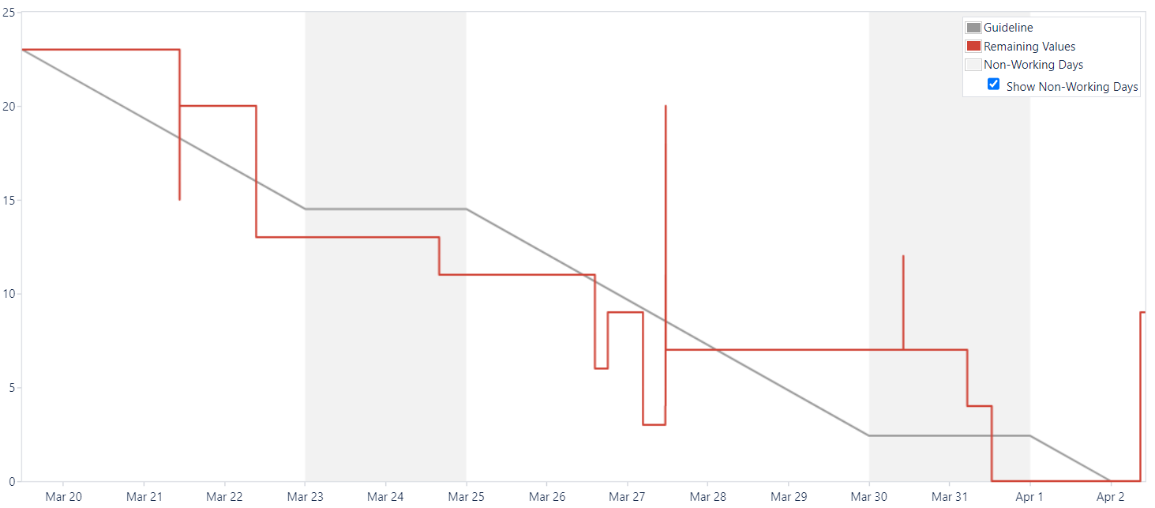

Figure 32: Burndown Chart

### **10.9. Schedule**

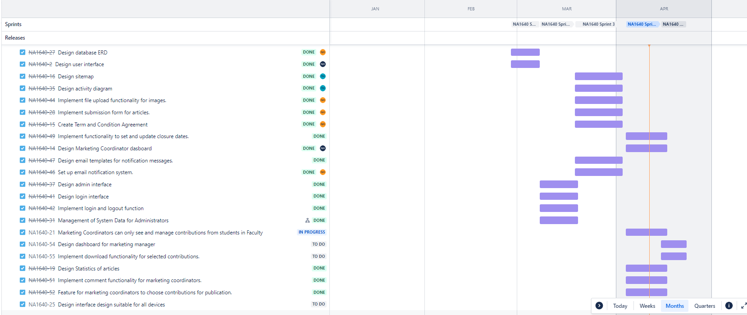

Figure 33: Schedule

## **11. Wireframe**

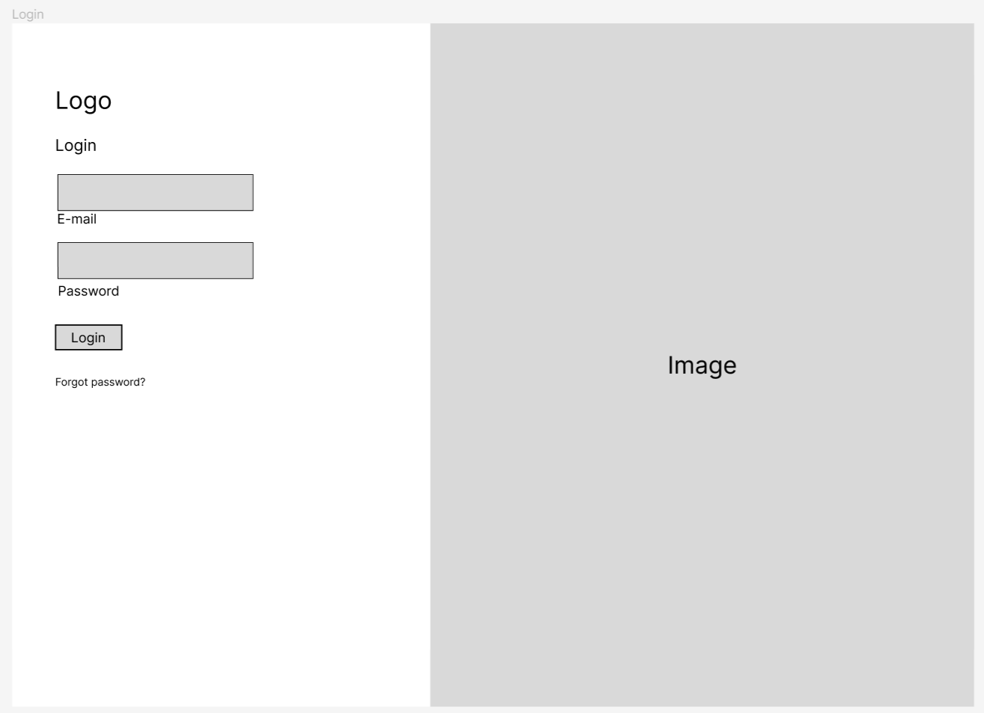

Figure 34: Login (Wireframe)

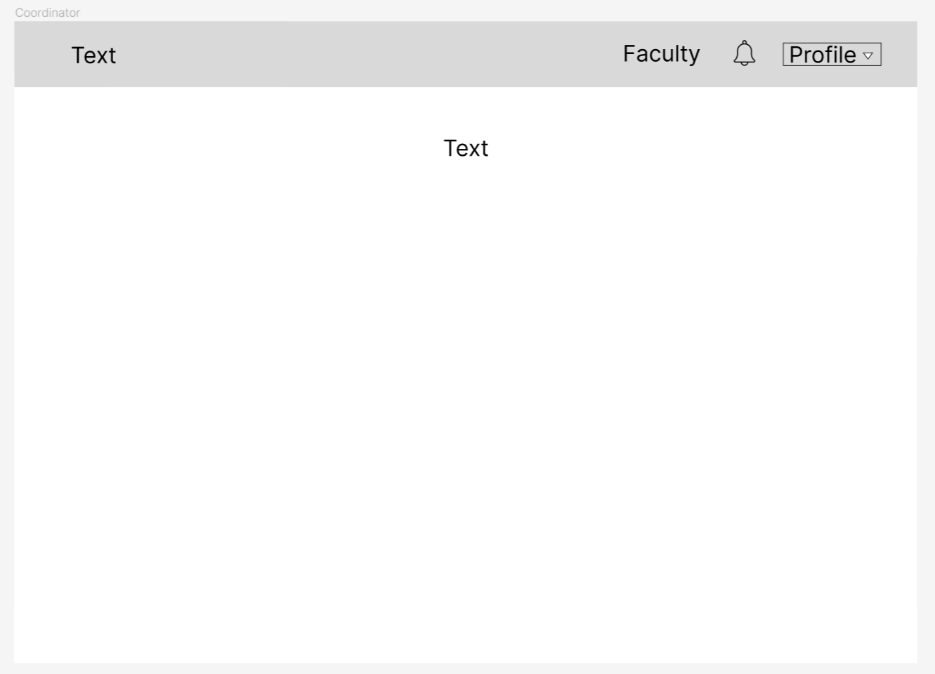

Figure 35: Coordinator (Wireframe)

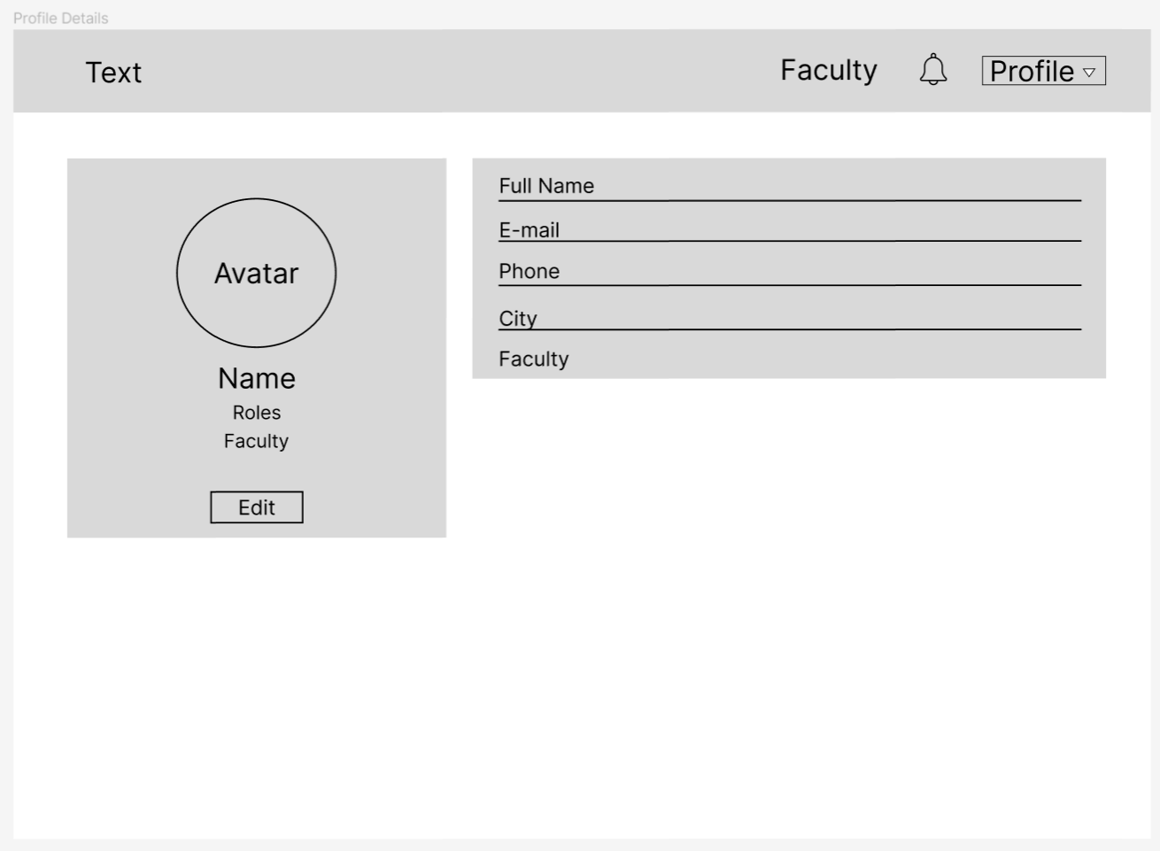

Figure 36: Profile Details (Wireframe)

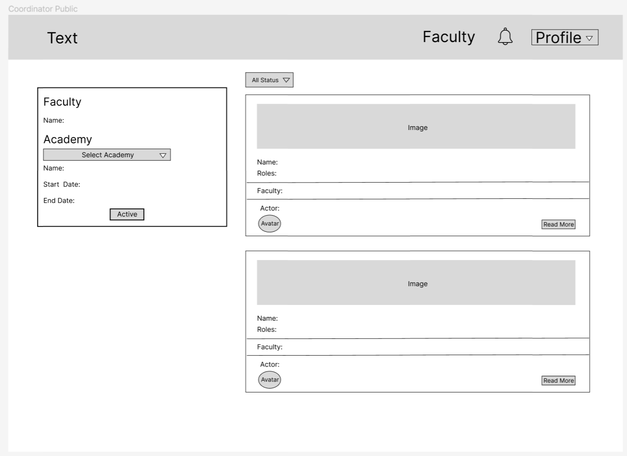

Figure 37: Coordinator Public (Wireframe)

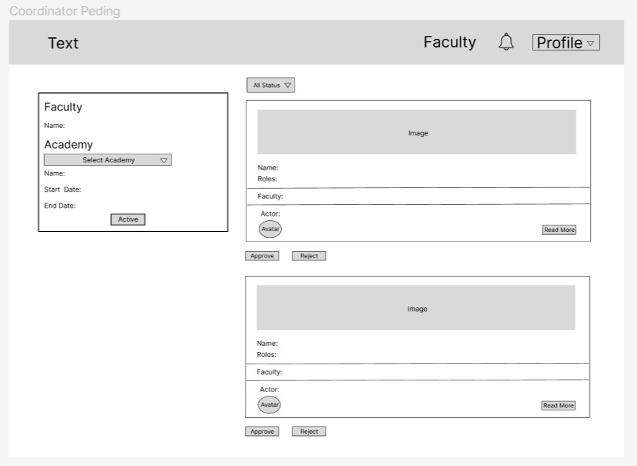

Figure 38: Coordinator Pending

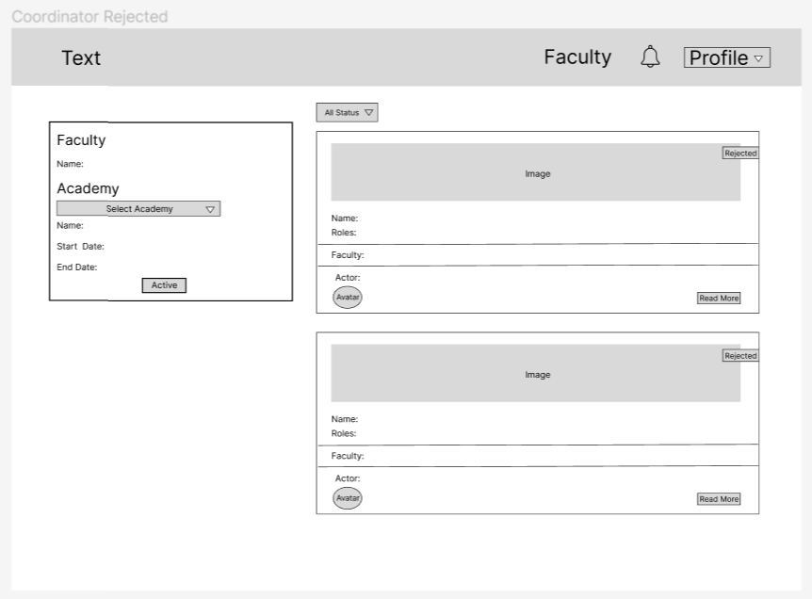

Figure 39: Coordinator Rejected (Wireframe)

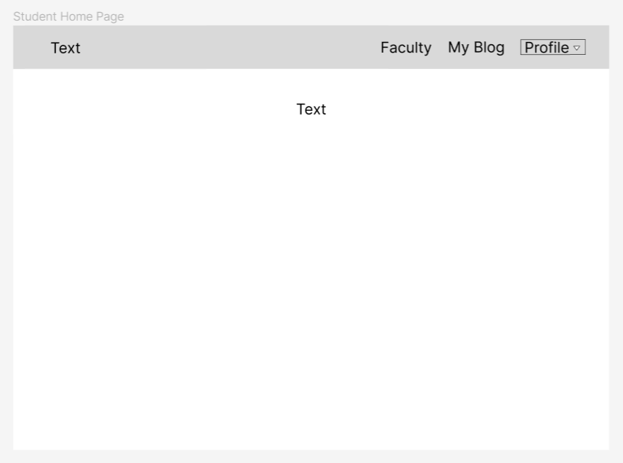

Figure 40: Student Home Page

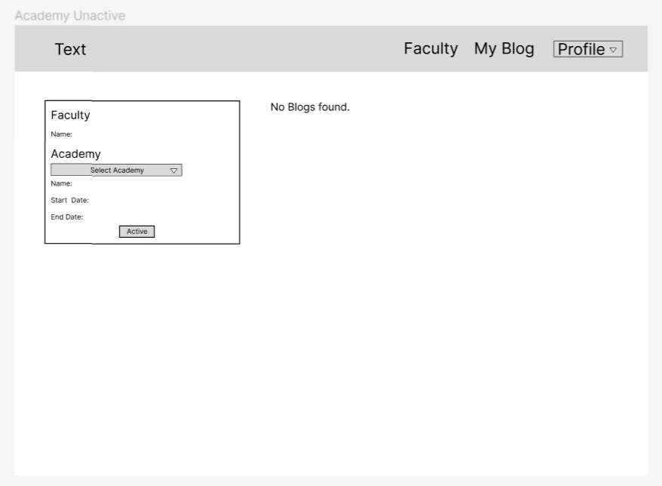

Figure 41: Academy Unactive (Wireframe)

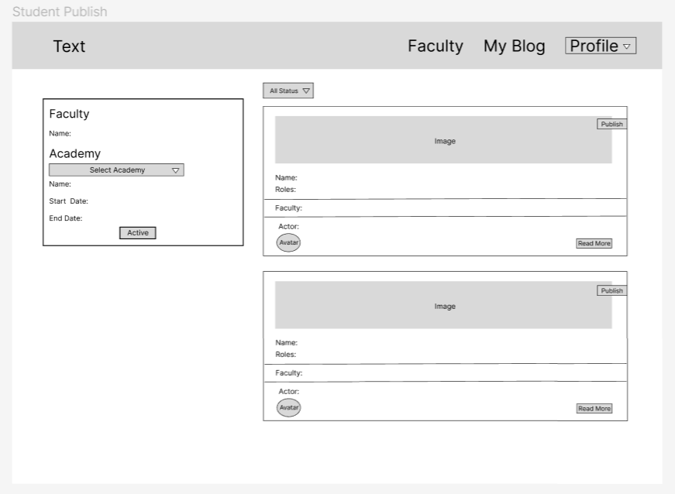

Figure 42: Student Publish

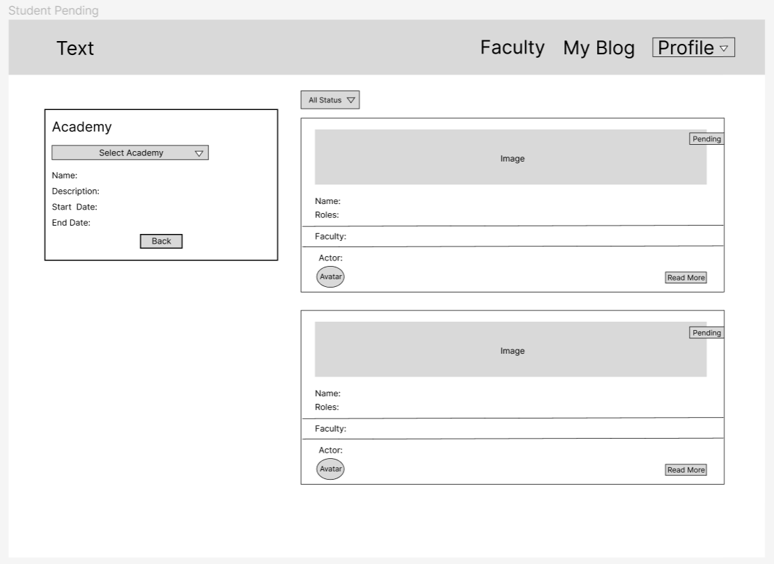

Figure 43: Student Pending

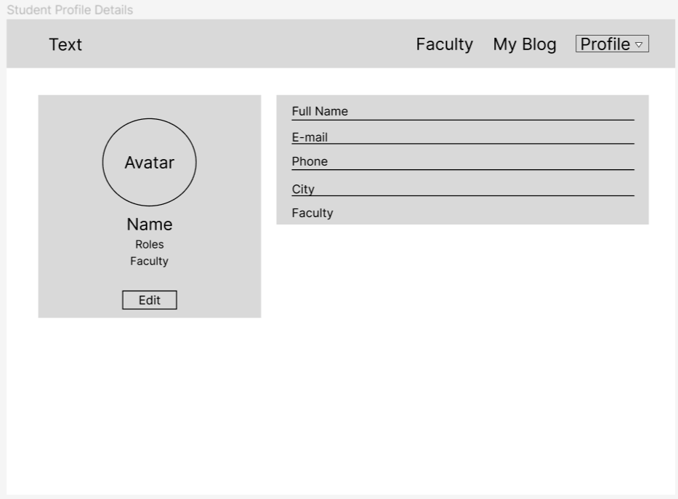

Figure 44: Student Profile Details

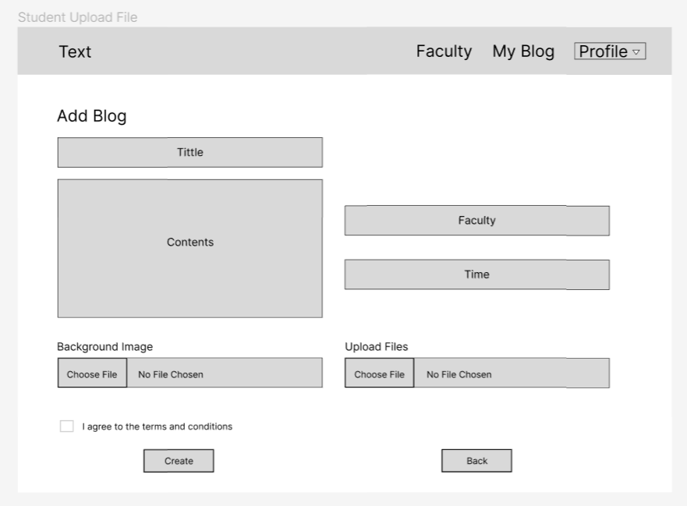

Figure 45: Student Upload File

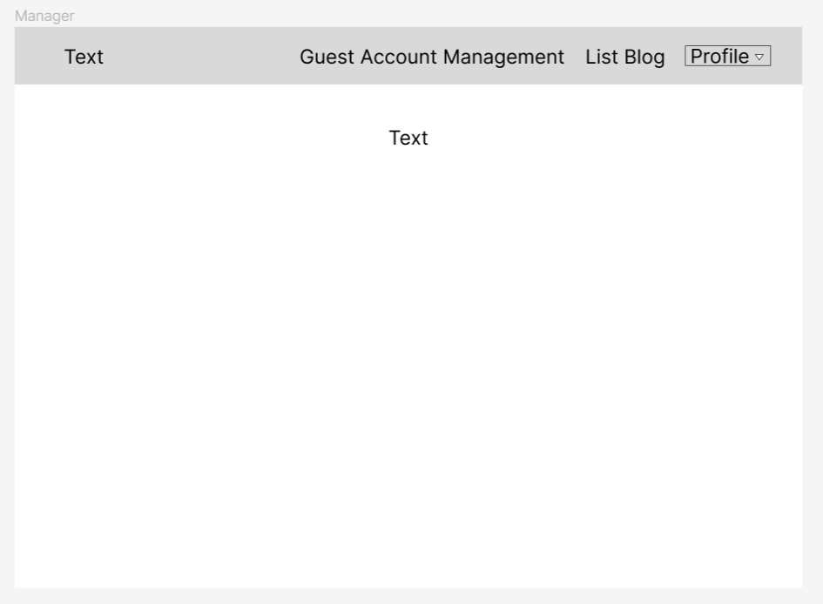

Figure 46: Manager (Wireframe)

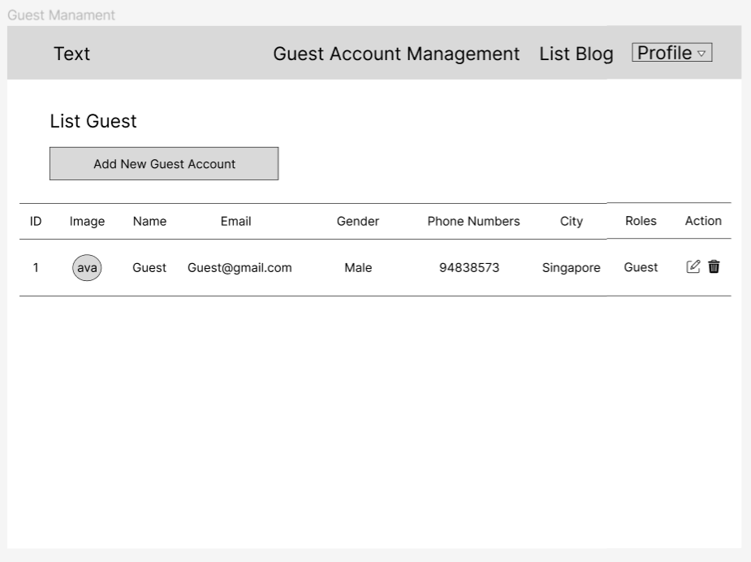

Figure 47: Guest Management (Wireframe)

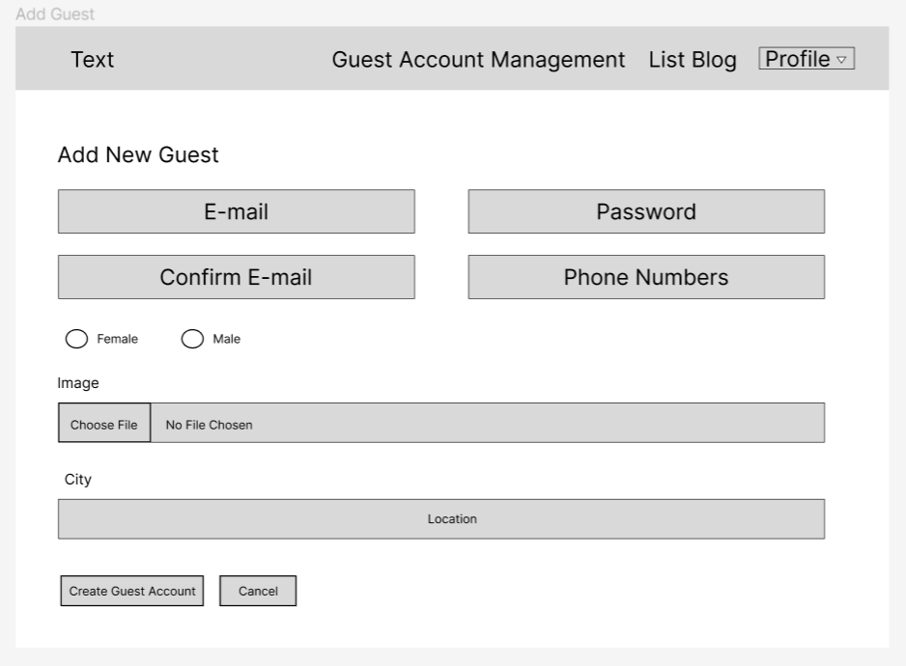

Figure 48: Add Guest (Wireframe)

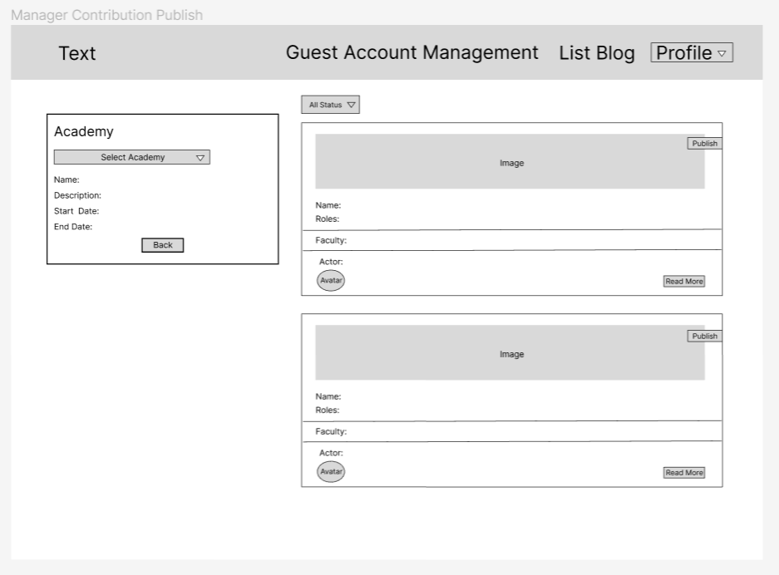

Figure 49: Manager Contribution Publish (Wireframe)

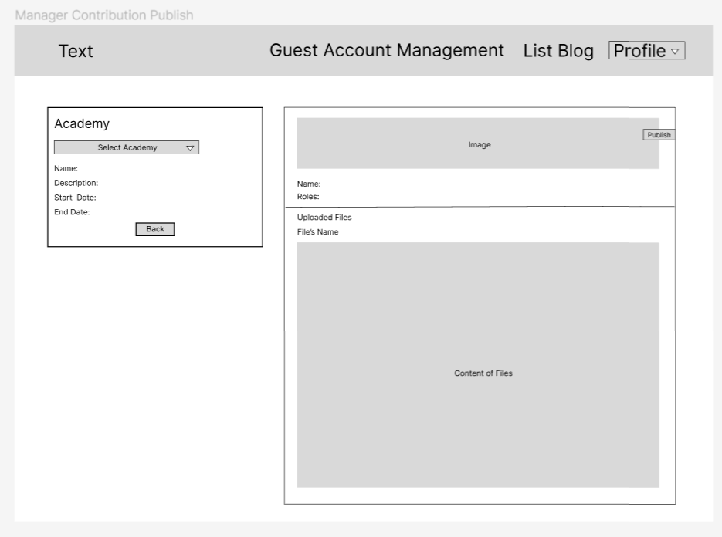

Figure 50: Manager Contribution Publish (Wireframe)

## **12. Product screenshots of your actual application and its functions**

Admin home page

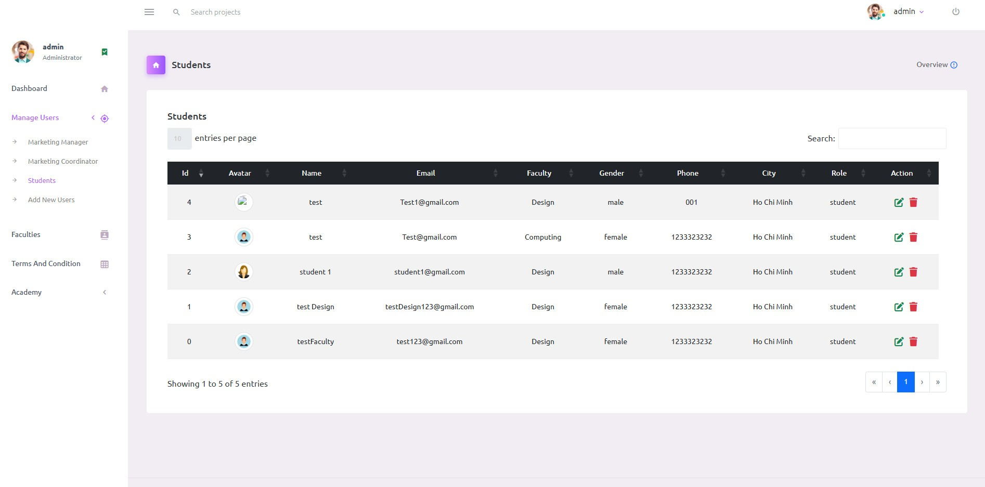

Figure 51: Admin Home Page

Admin add user account page

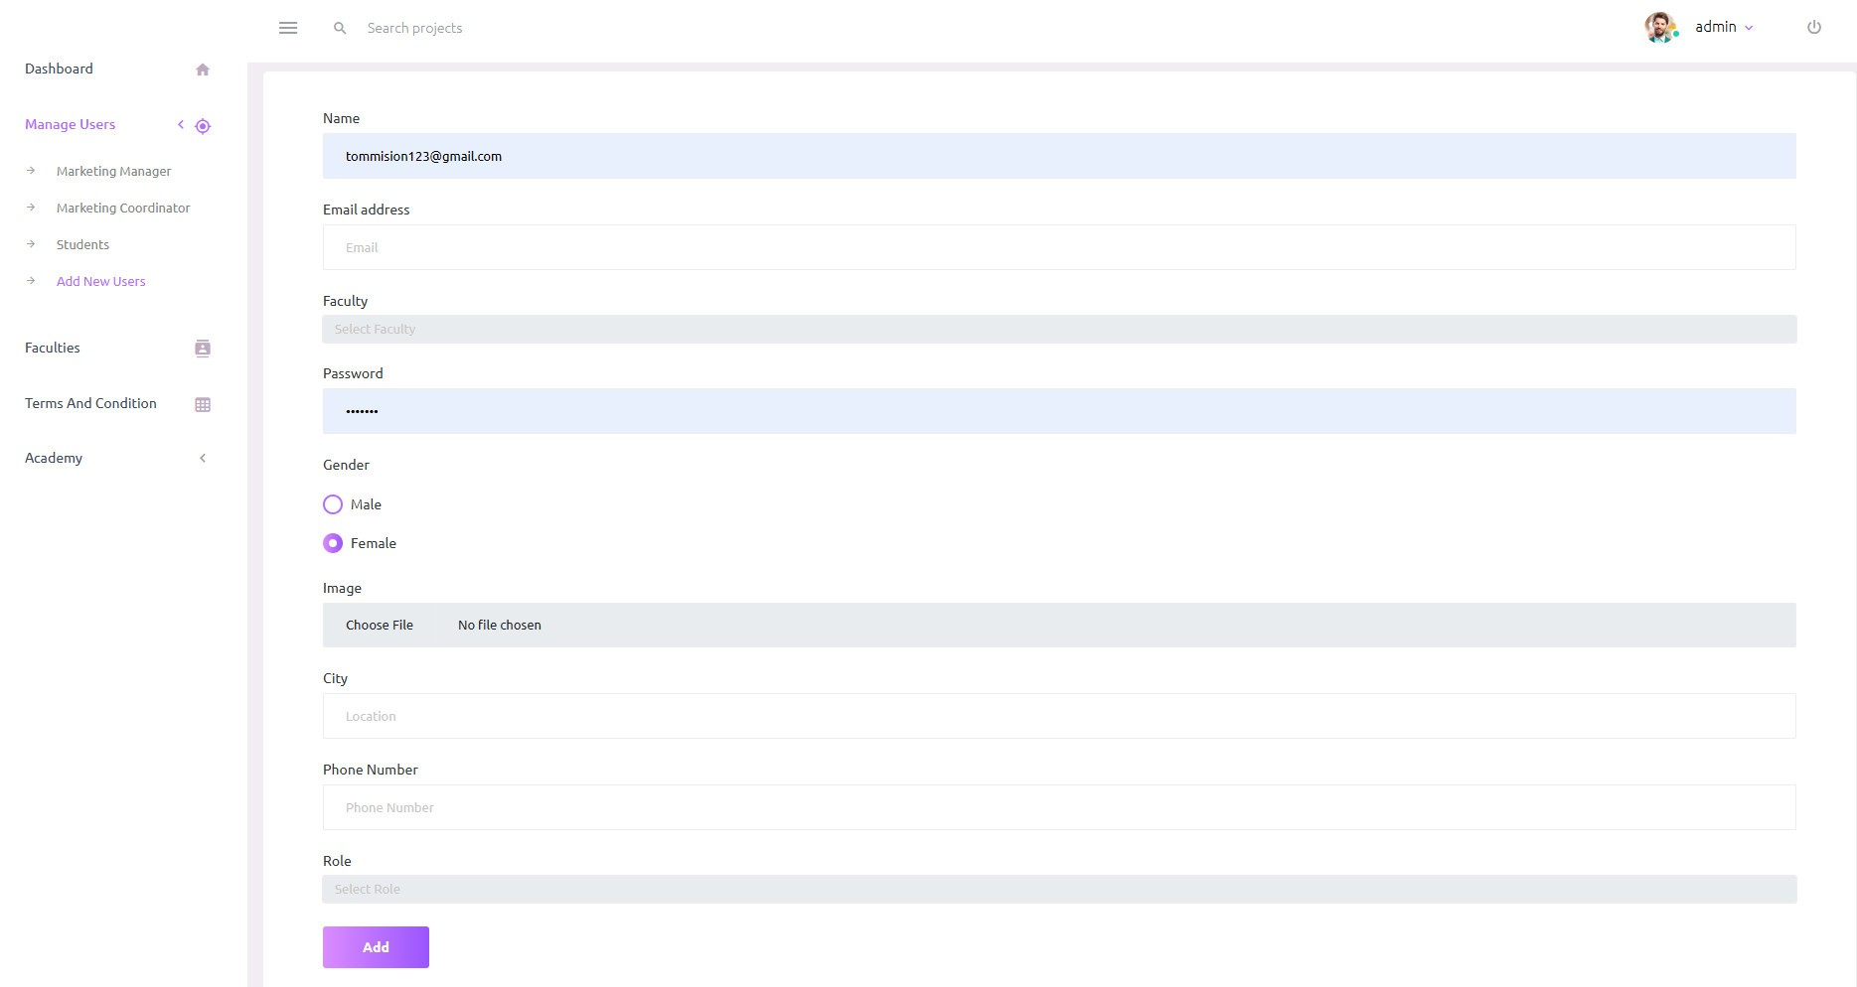

Figure 52: Admin Add User Account Page

Admin manage the faculty page

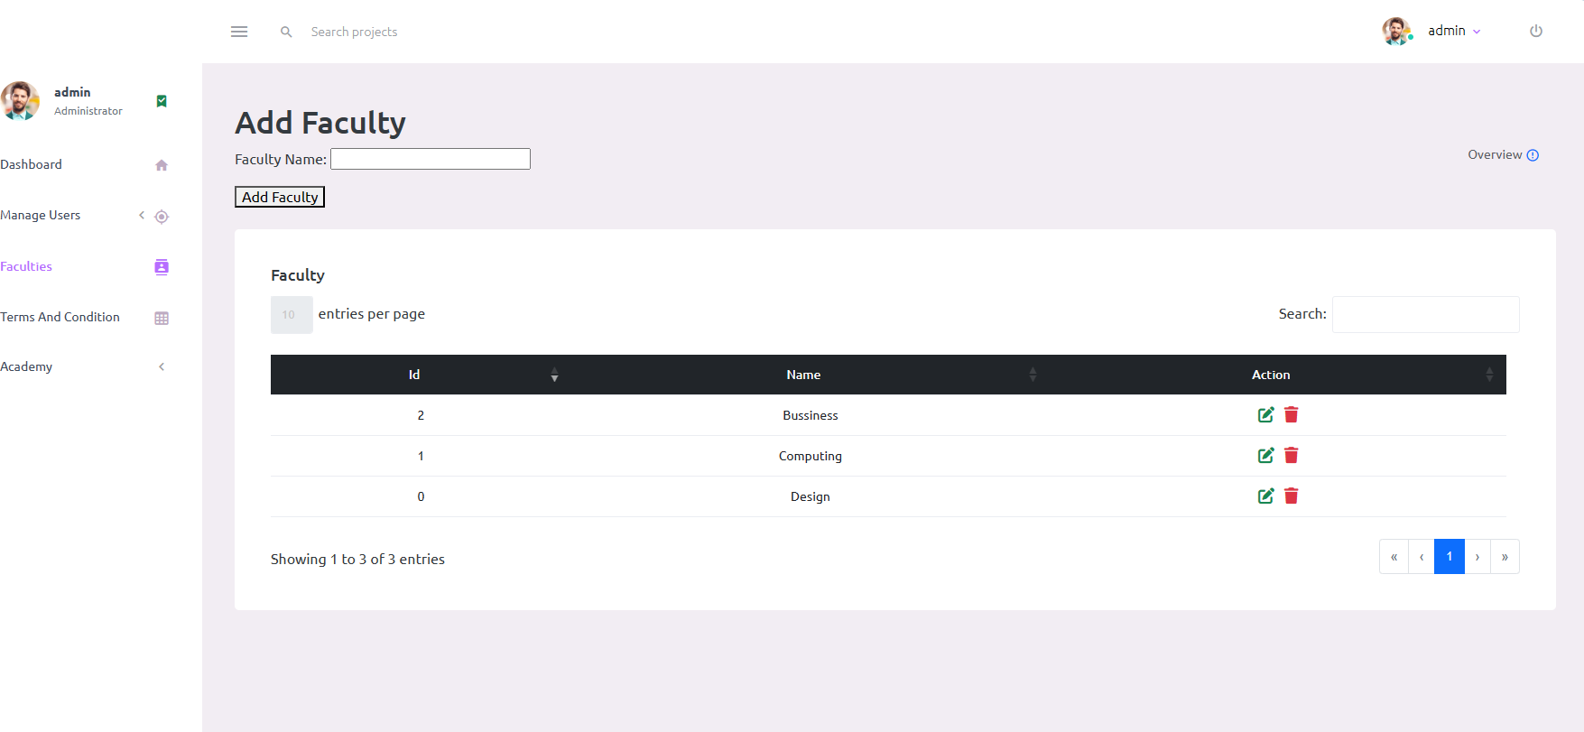

Figure 53: Admin Manage the Faculty Page

Admin manage the Academy year

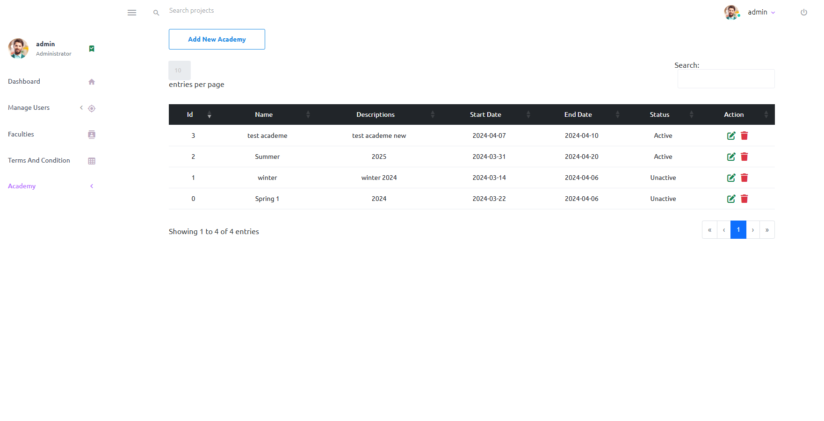

Figure 54: Admin Manage the Academy year

Marketing coordinator home page

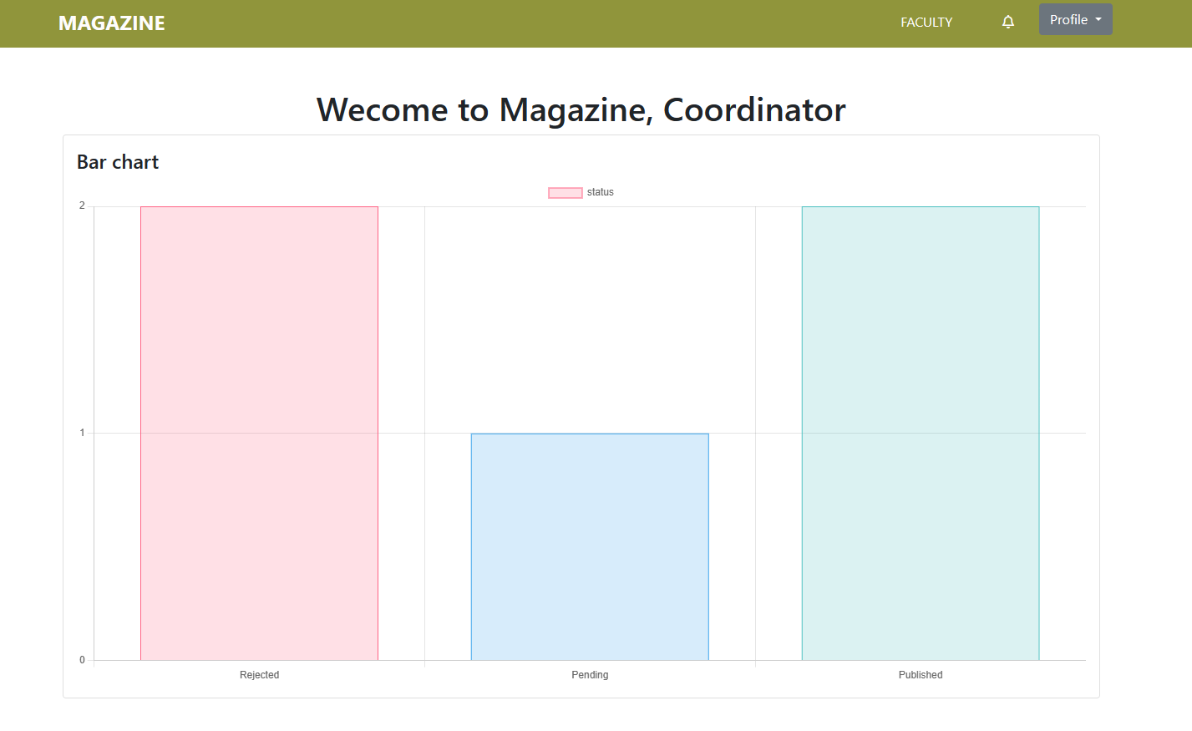

Figure 55: Marketing Coordinator Home Page

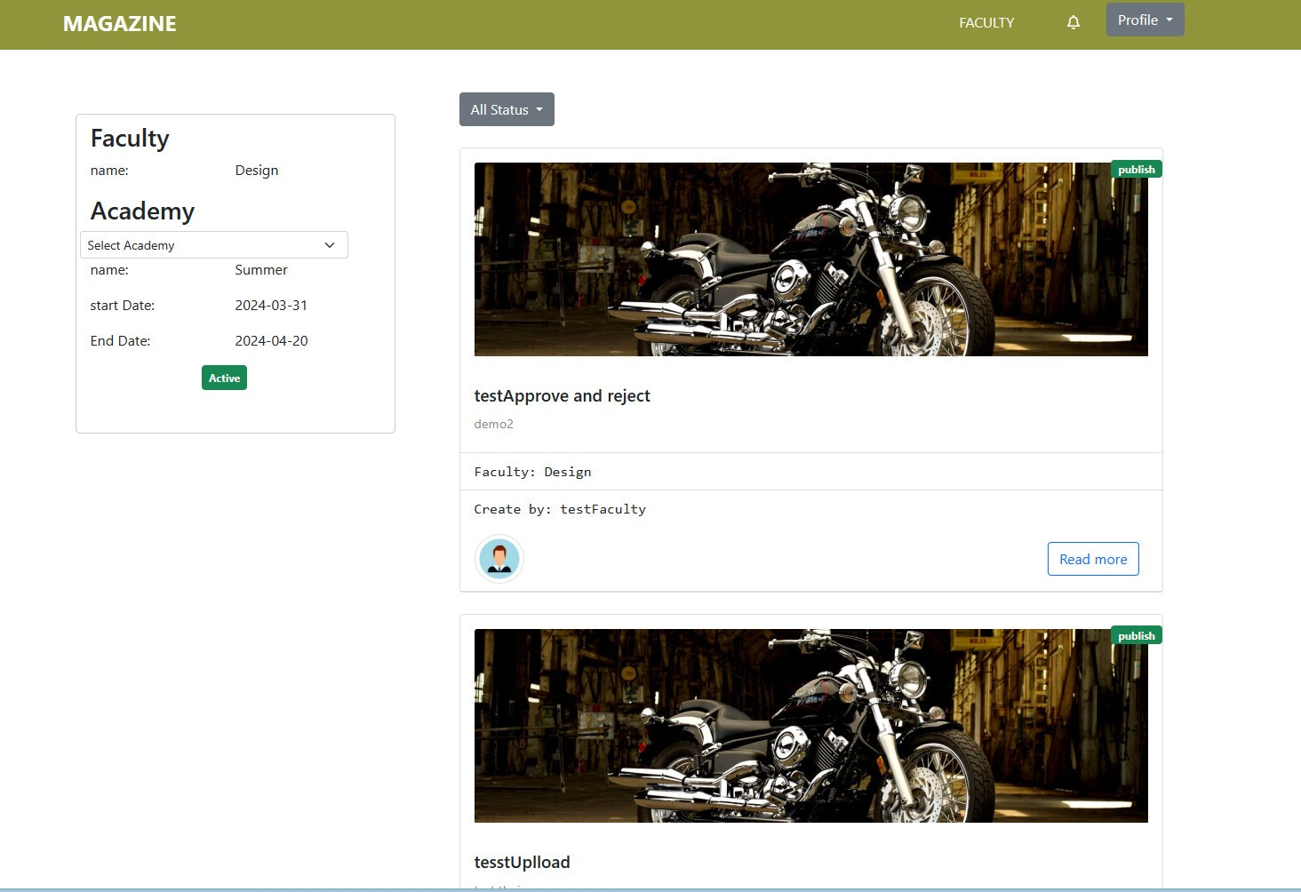

Figure 56: Coordinator List Blog

Contribution detail page

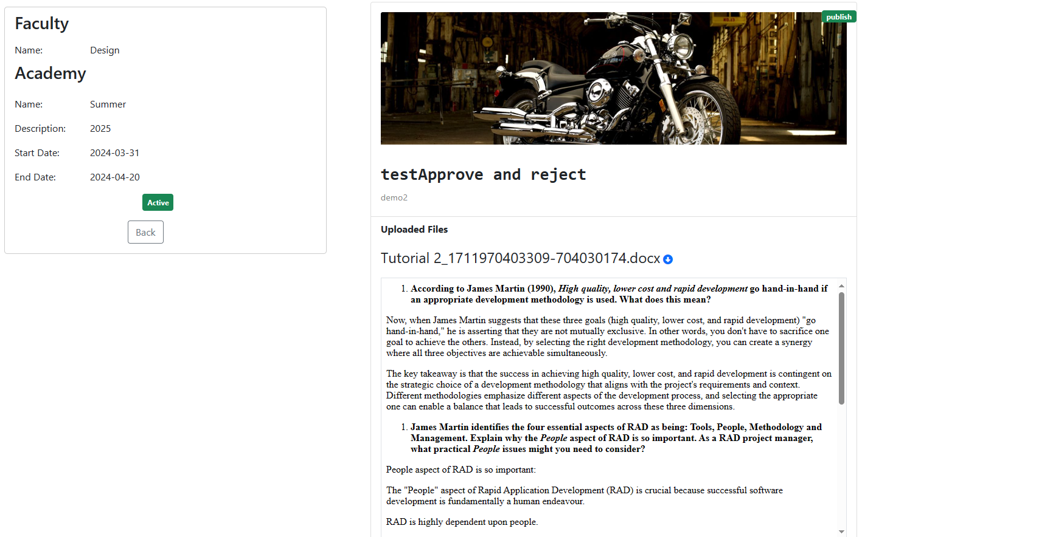

Figure 57: Contribution Detail Page

Marketing coordinator oversee the contribution of student

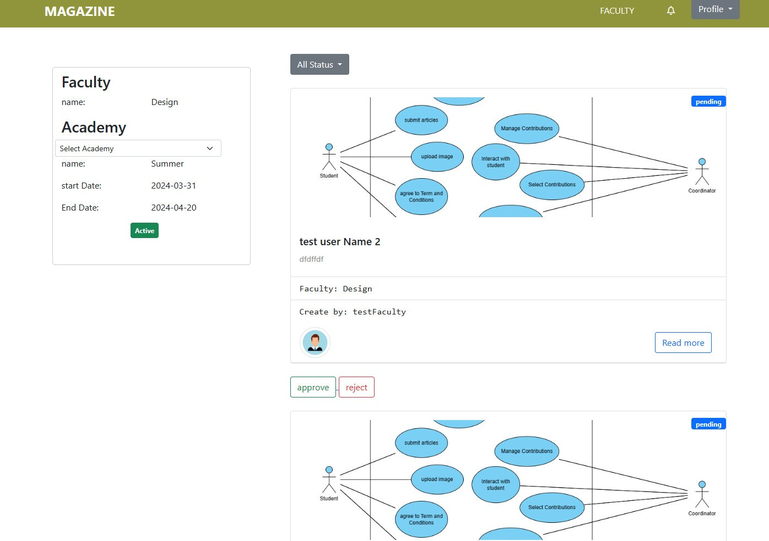

Figure 58: Marketing Coordinator Oversee the Contribution of Student

Marketing profile page

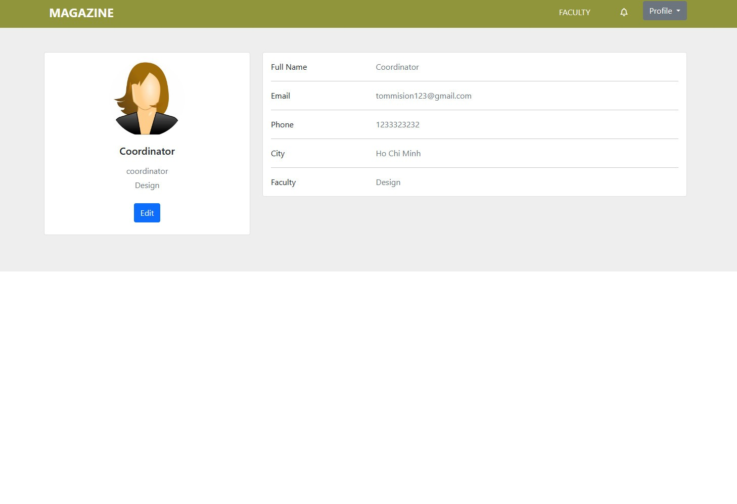

Figure 59: Marketing Profile Page

Login page



Figure 60: Login Page

Marketing manager home page

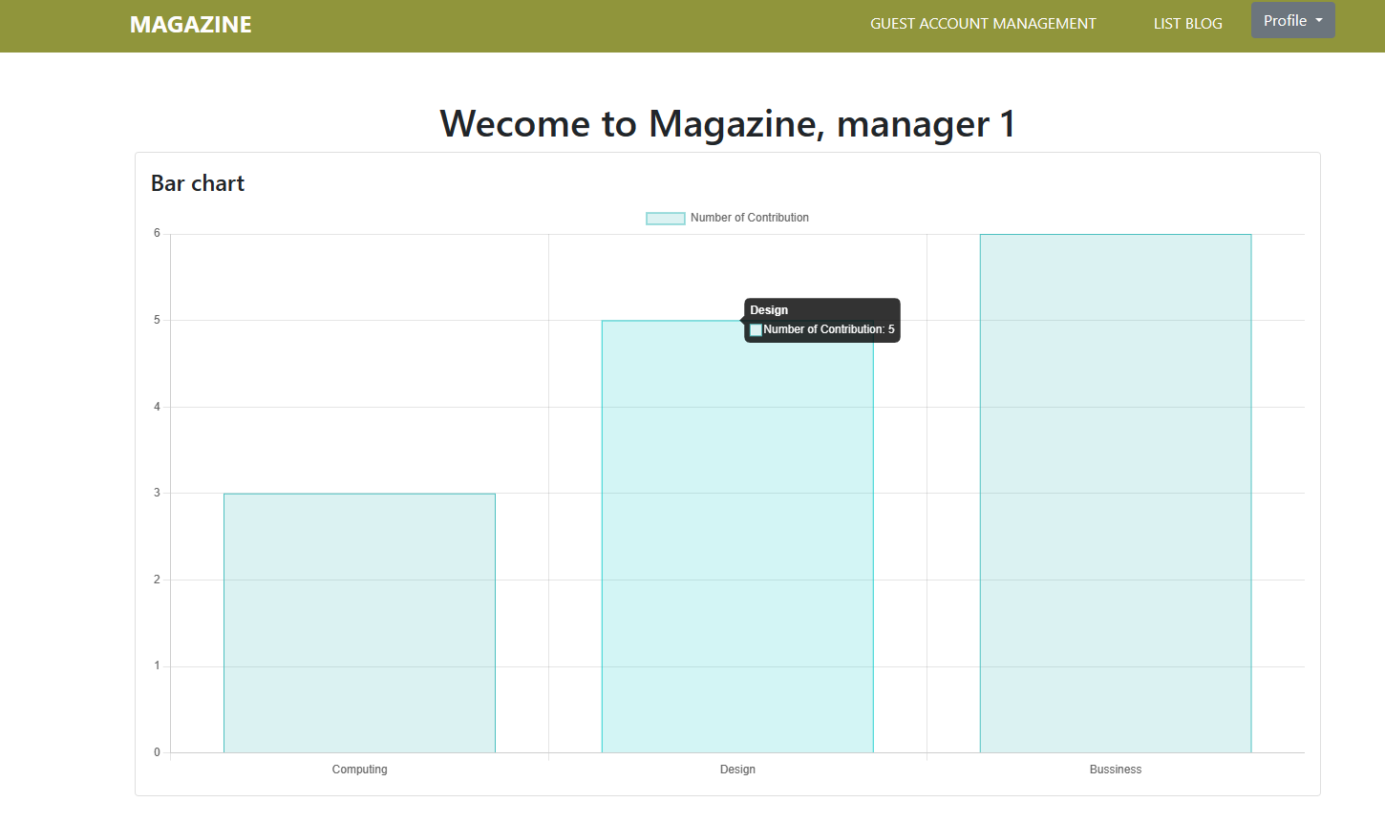

Figure 61: Marketing Manager Home Page

Management List Guest Account

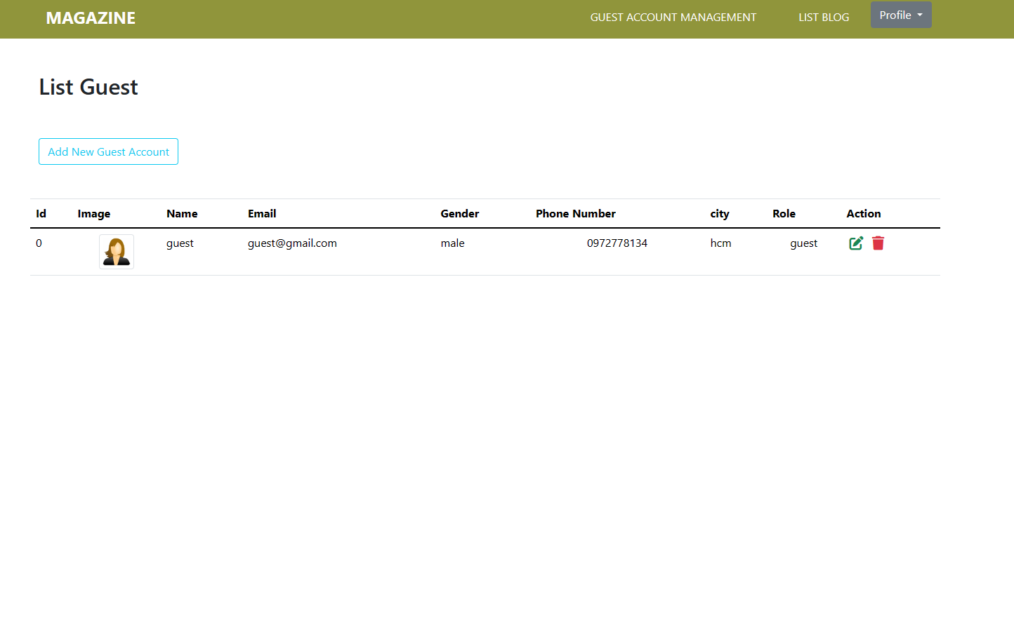

Figure 62: Management List Guest Account

Add new guest account

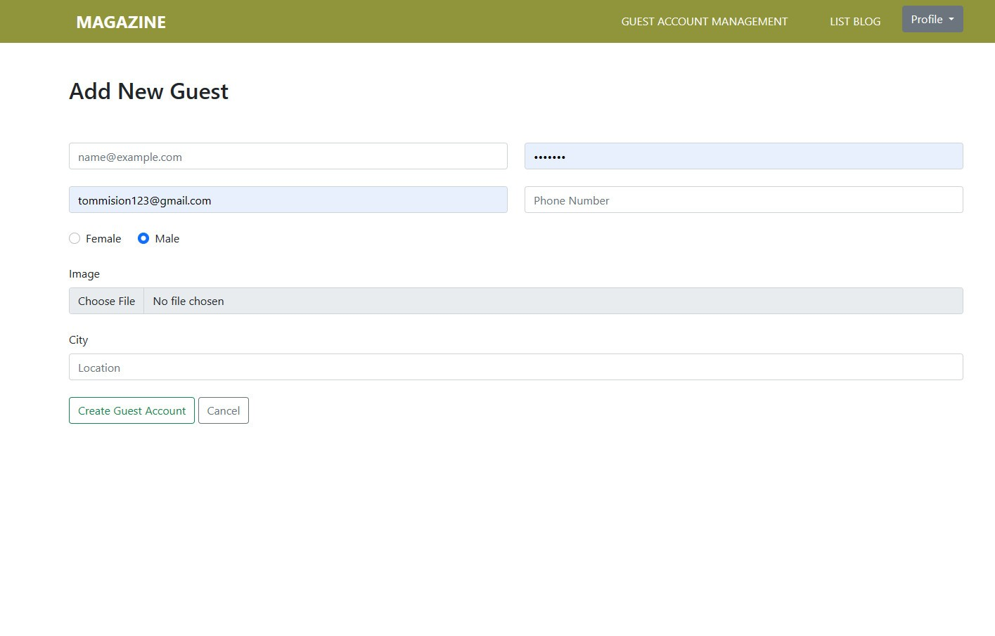

Figure 63: Add New Guest Account

Home Page for Guest

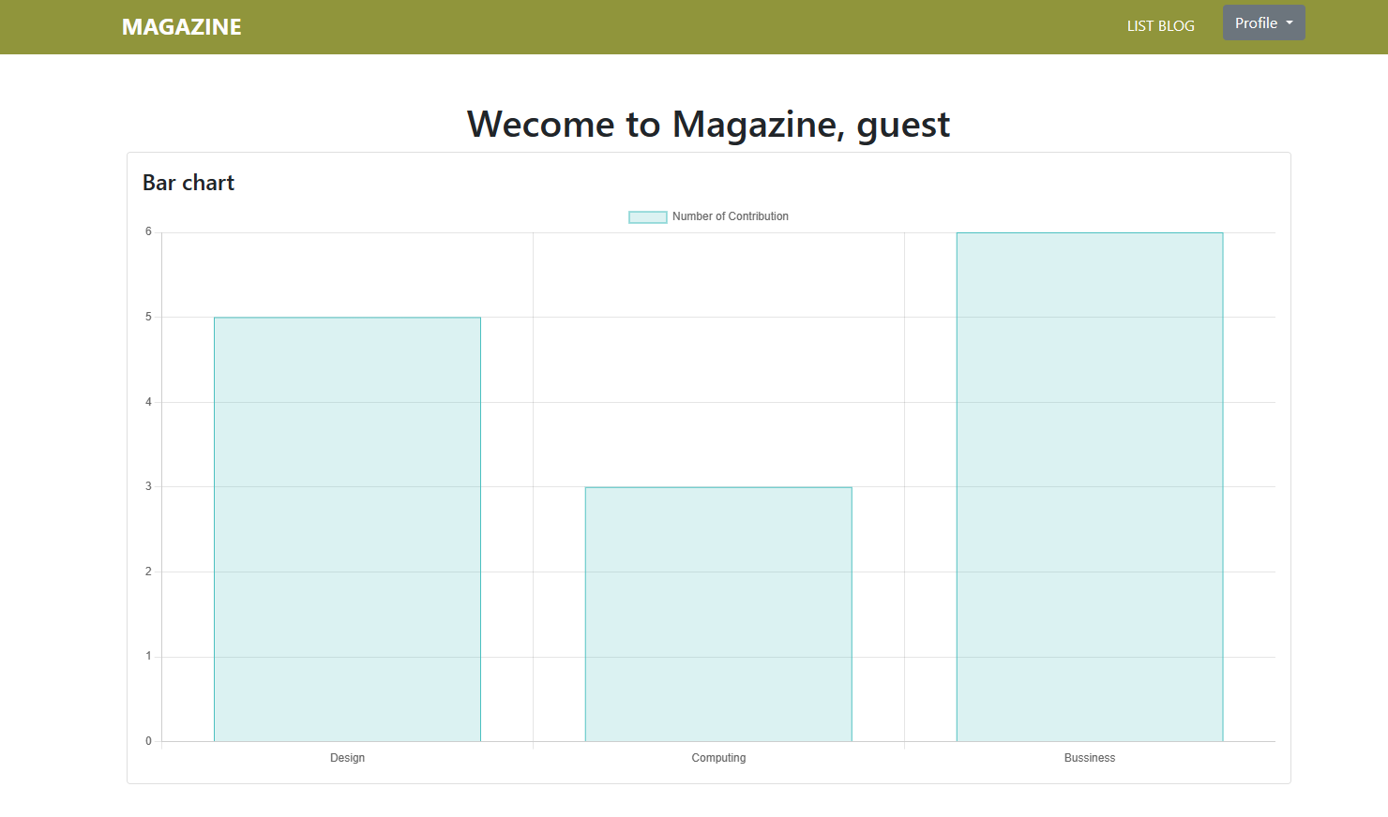

Figure 64: Home Page for Guest

Guest view the published contributions

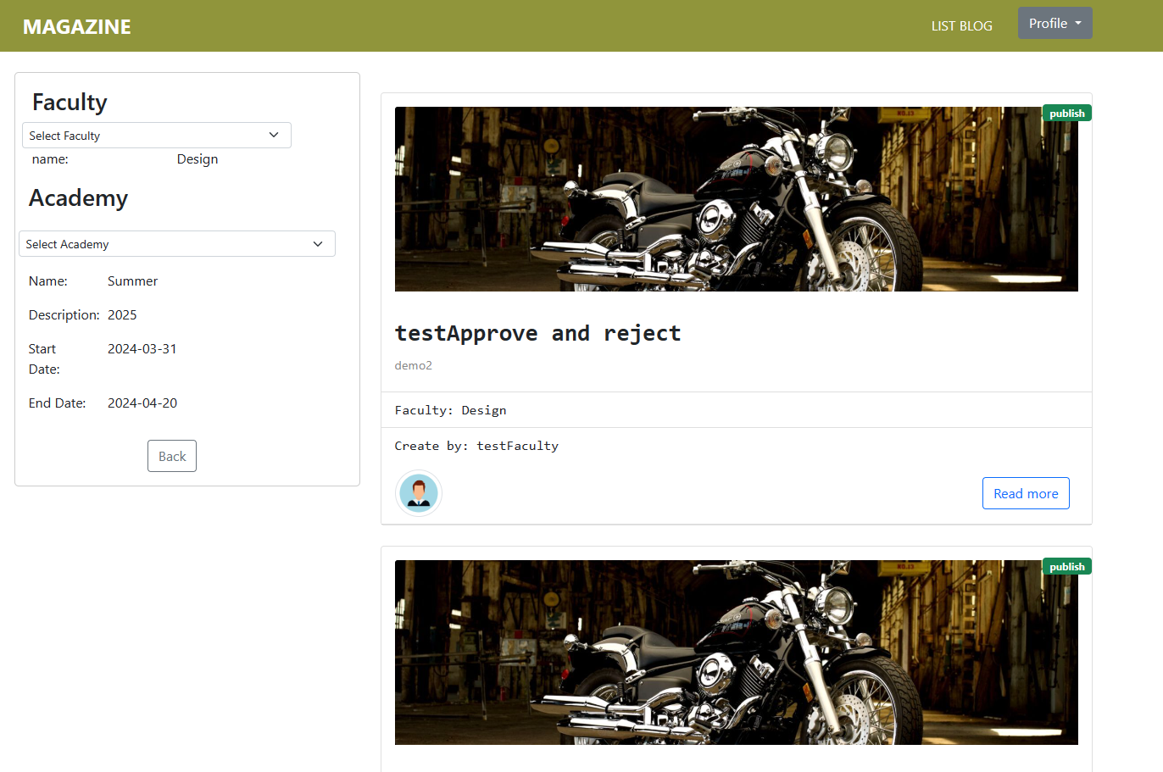

Figure 65: Guest view the Published Contributions

Student add a new contribution

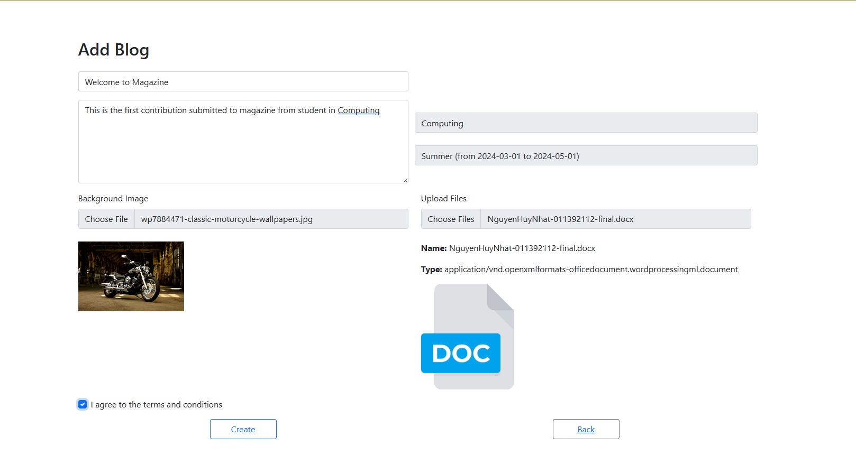

Figure 66: Student add a new contribution

When student add a new contribution successfully

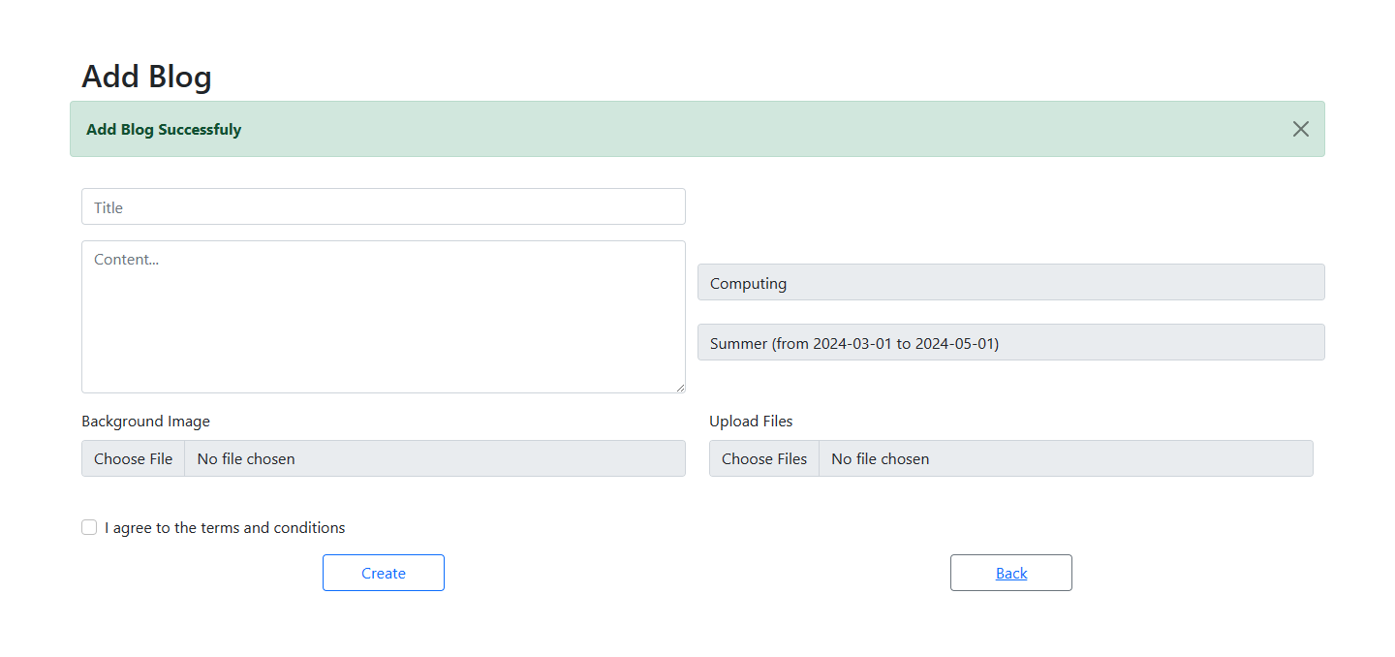

Figure 67: When student add a new contribution successfully

## **13. Links: Source Codes (Github), Screencast (Youtube/Google Drive/Onedrive)**

Github: <https://github.com/nhattan23/CMS-Comp1640>

Screencast:

# **References:**

*Draw.io - free flowchart maker and diagrams online* (no date) *Flowchart Maker & Online Diagram Software*. Available at: https://app.diagrams.net/ (Accessed: 14 April 2024).

Doan, K. (2021) *[scrum framework] sprint review LÀ GÌ?*, *Scrum Viet*. Available at: <https://www.scrumviet.org/blog/scrum-framework-sprint-review-la-gi> (Accessed: 14 April 2024).

*Best practices for sprint review meeting: ScrumDesk, Meaningful Scrum* (2022) *ScrumDesk, Meaningful Agile*. Available at: <https://www.scrumdesk.com/start/manual-for-scrumdesk-start/sprint-review/#:~:text=The%20sprint%20review%20is%20a%20meeting%20of%20an,commitment%20given%20at%20the%20beginning%20of%20the%20sprint.> (Accessed: 14 April 2024).

(No date) *Your work - jira*. Available at: <https://dothanhdat.atlassian.net/jira/your-work> (Accessed: 14 April 2024).

(No date a) *Activity diagram - UML 2 tutorial | sparx systems*. Available at: <https://sparxsystems.com/resources/tutorials/uml2/activity-diagram.html> (Accessed: 14 April 2024).

(No date a) *Enterprise web development: Building HTML5 applications: From desktop to mobile: Fain, Yakov, Rasputnis, Victor, Tartakovsky, Anatole, Gamov, Viktor: 9781449356811: Amazon.com: Books*. Available at: <https://www.amazon.com/Enterprise-Web-Development-Building-Applications/dp/1449356818> (Accessed: 14 April 2024).

Asialive (no date) *Situs Asialive88: Daftar asialive 88 slot gacor*, *Asialive*. Available at: <http://enterprisewebbook.com/> (Accessed: 14 April 2024).

*Patterns: Implementing an SOA using an enterprise service bus (ESB)* (2013) *SlideShare*. Available at: <https://www.slideshare.net/kunalashar/patterns-implementing-an-soa-using-an-enterprise-service-bus-esb> (Accessed: 14 April 2024).

(No date a) *Cloud computing services - amazon web services (AWS)*. Available at: <https://aws.amazon.com/> (Accessed: 14 April 2024).

(No date a) *(PDF) Agile Software Development*. Available at: <https://www.researchgate.net/publication/235616359_Agile_Software_Development> (Accessed: 14 April 2024).

(No date) *Scaling Lean & Agile Development: Thinking and organizational tools for large-scale scrum: Larman, Craig, Vodde, Bas: 9780321480965: Amazon.com: Books*. Available at: <https://www.amazon.com/Scaling-Lean-Agile-Development-Organizational/dp/0321480961> (Accessed: 14 April 2024).

Gamma, E. *et al.* (no date) *Design patterns: Elements of reusable object-oriented software*, *O’Reilly Online Learning*. Available at: <https://www.oreilly.com/library/view/design-patterns-elements/0201633612/> (Accessed: 14 April 2024).

*Scrum: The art of doing twice the work in half the time* (no date) *Goodreads*. Available at: <https://www.goodreads.com/book/show/19288230-scrum> (Accessed: 14 April 2024).

Thomas, D. (no date) *The pragmatic programmer : Your journey to mastery*, *in SearchWorks catalog*. Available at: https://searchworks.stanford.edu/view/13833238 (Accessed: 14 April 2024).

Freeman, E. (2004) *Head first design patterns*, *Google Books*. Available at: <https://books.google.com/books/about/Head_First_Design_Patterns.html?id=GGpXN9SMELMC> (Accessed: 14 April 2024).

(No date a) *Brooks 1974 the mythical man-month essays on software ...* Available at: [https://github.com/AlexGalhardo/Software-Engineering/blob/master/Book - Brooks 1974  The Mythical Man-Month Essays on Software Engineering - 2nd Edition.pdf](https://github.com/AlexGalhardo/Software-Engineering/blob/master/Book%20-%20Brooks%201974 %20The%20Mythical%20Man-Month%20Essays%20on%20Software%20Engineering%20-%202nd%20Edition.pdf) (Accessed: 14 April 2024).

(No date a) *By Ken Schwaber - Agile Project Management with Scrum (microsoft professional) (1st edition) (1.2.2004): Schwaber: 8601234591351: Amazon.com: Books*. Available at: <https://www.amazon.com/Ken-Schwaber-Management-Microsoft-Professional/dp/B00HTJPJME> (Accessed: 14 April 2024).

(No date a) *Clean architecture_ a craftsman’s guide to software ...* Available at: [https://github.com/goldcoders/DSA/blob/master/(Robert C. Martin Series) Robert C. Martin - Clean Architecture_ A Craftsman’s Guide to Software Structure and Design-Prentice Hall (2017).pdf](https://github.com/goldcoders/DSA/blob/master/(Robert%20C.%20Martin%20Series)%20Robert%20C.%20Martin%20-%20Clean%20Architecture_%20A%20Craftsman’s%20Guide%20to%20Software%20Structure%20and%20Design-Prentice%20Hall%20(2017).pdf) (Accessed: 14 April 2024).